

DG MARKT
Framework Contract No DI/06769-00
Specific Contract N°010459

Digital Signature Services
Application Release
User Manual


ARHS Logo

Subject | User Manual
Version | 1.01
Release Date | 26/09/2013
Filename | 0000.doc
Document Reference | DSS-UM

Document History

Document History
Version | Release Date | Author | Description
0.90 | 30/06/2011 | Christian Hiedels, David Naramski, Yannick Schaus, Julien Stouffs | Version sent for Review
1.00 | 27/07/2011 | Christian Hiedels | Version sent for Acceptance
1.01 | 26/09/2013 | Nicolas Bouillon | Updated from changes of DSS v3 : new standard compliance for TLManager and new validation policy

Reviews
Version | Release Date | Reviewer | Position
0.90 | 30/06/2011 | Frank Meyer | Project Manager
1.00 | 27/07/2011 | Frank Meyer | Project Manager
1.01 | 26/09/2013 | Yannick Vincent | Project Manager

Table Of Contents

Reference and Applicable Documents 11
Abbreviations and Acronyms 13
1 Introduction 15
1.1 Purpose of the Document 15
1.2 Scope of the Document 15
1.3 Intended Audience 15
1.4 Structure of the Document 15
2 DSS/Web 16
2.1 Technical Requirements 16
2.2 DSS Applet Overview 16
2.3 Signing a Document 17
2.3.1 Choosing the Document to Sign 17
2.3.2 Choosing the Signature Characteristics 18
2.3.2.1 Signature Format 19
2.3.2.2 Signature Packaging 19
2.3.2.3 Signature Level 19
2.3.2.4 Wrap in ASiC-S 19
2.3.3 Providing the Signature Token 19
2.3.3.1 Selecting the Signature Token API 19
2.3.3.1.1 Using PKCS#11 20
2.3.3.1.2 Using PKCS#12 21
2.3.3.1.3 Using MS CAPI 21
2.3.3.2 Choosing the Signing Certificate 22
2.3.4 Supplying Additional Extended Signature Properties 23
2.3.4.1 Signer Claimed Role 23
2.3.4.2 Signature Policy 23
2.3.5 Selecting the Signed File Location 24
2.3.6 Finishing the Signature Generation Process 24
2.4 Verifying a Document Signature 26
2.4.1 Selecting the Input 26
2.4.2 Viewing the Validation Report 26
2.4.2.1 TimeInformation Node 27
2.4.2.2 SignatureInformation Nodes 27
2.4.2.2.1 Signature structure verification 27
2.4.2.2.2 Signature verification 27
2.4.2.2.3 Signature algorithm 28
2.4.2.2.4 CertPathRevocationAnalysis 28
2.4.2.2.5 SignatureLevelAnalysis 29
2.4.2.2.6 QualificationsVerification 32
2.4.2.2.7 QCStatementInformation 32
2.4.2.2.8 Final Conclusion 33
2.5 Extending a Previously Created Signature 34
2.5.1 Selecting the Signature to Extend 34
2.5.2 Selecting the Target Level 34
2.5.3 Selecting the Extended File Location 35
2.5.4 Finishing the Signature Extension Process 35
3 TLManager 36
3.1 Technical Requirements 36
3.2 TLManager overview 36
3.3 Interface features 37
3.3.1 Navigation tree 38
3.3.2 Colour convention 38
3.3.3 Multilingual values 39
3.3.3.1 Structure 39
3.3.3.1.1 Available content area for multilingual values 40
3.3.4 Multiple values 41
3.3.4.1 Structure 41
3.3.4.1.1 Available content area for multiple values 42
3.3.5 Certificate viewer 44
3.3.5.1 Structure 44
3.4 Create a new Trusted List 46
3.5 Open an existing Trusted List 47
3.5.1 Invalid TSL 47
3.6 Edit a Trusted List 48
3.6.1 Edit TSL information 49
3.6.1.1 TSL Sequence Number 50
3.6.1.2 TSL type 50
3.6.1.3 Scheme Operator Name 50
3.6.1.4 Scheme Operator Postal Address 51
3.6.1.5 Scheme Operator Electronic Address 51
3.6.1.6 Scheme Name 51
3.6.1.7 Status Determination Approach 51
3.6.1.8 Scheme Information URI 51
3.6.1.9 Scheme Type community Rule 51
3.6.1.10 Scheme Territory 51
3.6.1.11 Policy or Legal Notice 51
3.6.1.12 List Issue Date 51
3.6.1.13 Closed 52
3.6.1.14 Next Update 52
3.6.1.15 Distribution Point 52
3.6.1.16 TSL Identifier 52
3.6.2 Add a pointer to other Trusted List 52
3.6.2.1 Digital ID 53
3.6.2.2 TSL Type 53
3.6.2.3 TSL location 53
3.6.2.4 Scheme operator Name 54
3.6.2.5 Scheme Type Community Rule 54
3.6.2.6 Scheme Territory 54
3.6.2.7 Mime Type 54
3.6.3 Add a Trusted Service Provider 54
3.6.3.1 TSP Name 55
3.6.3.2 TSP Trade Name 55
3.6.3.3 TSP Postal Address 55
3.6.3.4 TSP Electronic Address 55
3.6.3.5 TSP Information URI 55
3.6.3.6 TSP Information Extension 56
3.6.4 Add a service to a Trusted Service Provider 56
3.6.4.1 Service Type Identifier 57
3.6.4.2 Service Name 58
3.6.4.3 Digital ID 58
3.6.4.4 Service Current Status 58
3.6.4.5 Current status Starting Date 59
3.6.4.6 Scheme Service Definition URI 59
3.6.4.7 Service Supply Point 59
3.6.4.8 TSP Service Definition URI 59
3.6.5 Add a service information extension 59
3.6.5.1 Taken over by 61
3.6.5.2 Expired Certificates Revocation Information 61
3.6.5.3 Additional Service Information 61
3.6.6 Add a qualification extension 61
3.6.7 Add a service history 64
3.6.7.1 Service Type Identifier 65
3.6.7.2 Service Name 66
3.6.7.3 Digital ID 66
3.6.7.4 Service Previous Status 66
3.6.7.5 Previous Status Starting Date 66
3.6.7.6 Mandatory fields 66
3.7 Save the current Trusted List 66
3.7.1 First Save 67
3.8 Sign the current Trusted List 67
3.8.1 Step 1: Validate the Trusted List 67
3.8.1.1 Mandatory fields verification 68
3.8.1.1.1 TSL information page: 68
3.8.1.1.2 Pointer to other TSL page: 69
3.8.1.1.3 TSP information page: 69
3.8.1.1.4 Service current status information page: 69
3.8.1.1.5 Taken over by extension: 69
3.8.1.1.6 Additional service information extension: 70
3.8.1.1.7 ExpiredCertsRevocationInfo extension: 70
3.8.1.1.8 Qualifications extension: 70
3.8.1.1.9 Service status history page: 70
3.8.1.2 Business rules verification 70
3.8.1.2.1 TSL information page 70
3.8.1.2.2 Pointer to other TSL 71
3.8.1.2.3 Service current status information page 71
3.8.1.2.4 ExpiredCertsRevocationInfo extension: 71
3.8.1.2.5 Qualifications extension 72
3.8.1.2.6 Service status history page 72
3.8.1.2.7 Service type identifier 72
3.8.1.2.8 Service digital identifier 72
3.8.1.2.9 Service information extensions 72
3.8.1.2.10 Previous status starting date 72
3.8.2 Step 2: Choose the signature method 72
3.8.2.1 PKCS#11 72
3.8.2.2 PKCS#12 73
3.8.2.3 MS CAPI 75
3.8.3 Step 3: Select the signing certificate and output file 75
3.8.3.1 PKCS#11 PIN code 76
3.8.3.2 MS CAPI PIN code 77
3.8.4 Step 4: Signature confirmation 78
3.9 Consult the validation result 78
3.10 Remove a TSL element 79
4 Annex I: Editing modes of TLManager 81
4.1 Trusted List configuration 81
4.2 List of Trusted List configuration 83

List of Tables

Table 1: Reference Documents 11
Table 2: Applicable Documents 12
Table 3: Abbreviations and Acronyms 14
Table 4: Technical Requirements 16
Table 5: Final conclusion matrix 33
Table 6: Technical Requirements 36
Table 7: Editing options 49

List of Figures

Figure 1: "Choose an activity" panel 16
Figure 2: File to sign selection panel 17
Figure 3: File picker dialog 18
Figure 4: Signature format, packaging, level panel 18
Figure 5: Signature Token API panel 19
Figure 6: PKCS#11 library selection panel 20
Figure 7: PKCS#12 file selection and password input panel 21
Figure 8: Signing certification selection panel 22
Figure 9: Additional extended signature properties panel 23
Figure 10: Specifying an explicit signature policy 24
Figure 11: Output signed file selection panel 24
Figure 12: Signature created successfully 25
Figure 13: Signature creation failed 25
Figure 14: Signed file and content to verify selection panel 26
Figure 15: Validation report tree viewer panel 27
Figure 16: Signed file to extend and content selection panel 34
Figure 17: Target level selection panel 34
Figure 18: Extended output file selection panel 35
Figure 19: TLManager Main screen 37
Figure 20: Example of navigation tree 38
Figure 21: Multilingual values button 39
Figure 22: Duplicate a language entry 40
Figure 23: Example of multilingual textfield interface 40
Figure 24: Example of multilingual postal address interface 41
Figure 25: Multiple values button 41
Figure 26: Example of multiple textfield interface 42
Figure 27: Example of multiple address interface 42
Figure 28: Example of multiple selection interface 43
Figure 29: Example of multiple information extension interface 43
Figure 30: Example of multiple additional information interface 44
Figure 31: Certificate viewer 45
Figure 32: Certificate file selection dialog 46
Figure 33: Main menu – New 46
Figure 34: Confirmation dialog 46
Figure 35: File selection dialog 47
Figure 36: Invalid file error 47
Figure 37: TL expected error 48
Figure 38: LOTL expected error 48
Figure 39: TSL information page 50
Figure 40: TSL Node contextual menu 52
Figure 41: Pointer to other TSL page 53
Figure 42: TSL Node contextual menu 54
Figure 43: TSP information page 55
Figure 44:"Trusted Service Provider" Node contextual menu 56
Figure 45: Service current status information page 57
Figure 46: "Trust Service" node contextual menu 60
Figure 47: Service information extension page 60
Figure 48: "Extensions" node contextual menu 62
Figure 49: Qualification page 62
Figure 50: "Trust Service" node contextual menu 64
Figure 51: New service status values 65
Figure 52: Service status history page 65
Figure 53: Create service history error 66
Figure 54: Save dialog box 67
Figure 55: Trusted List validation 68
Figure 56: Certificate source and signature method – PKCS#11 73
Figure 57: Certificate source and signature method – PKCS#12 74
Figure 58: Certificate source and signature method – MS CAPI 75
Figure 59: Select signing certificate and destination file 76
Figure 60: Example of PKCS#11 PIN introduction 77
Figure 61: MS CAPI PIN code introduction 77
Figure 62: Signature confirmation 78
Figure 63: Validation results 79
Figure 64: Example of contextual menu 79
Figure 65: Confirm removal 80

Reference and Applicable Documents
This section contains the lists of all reference and applicable documents. When referring to any of the documents below, the bracketed reference will be used in the text, such as [R01].

Reference Documents
Ref. | Title | Reference | Version | Date
R01 | Services Directive 2006/123/EC | 2006/123/EC | 1.00 | 12/12/2006
R02 | Commission Decision 2009/767/EC (corrected version) | CD 2009/767/EC | 1.00 | 14/11/2009
R03 | Commission Decision 2010/425/EU | CD 2010/425/EU | 1.00 | 28/07/2010
R04 | XAdES Specification | ETSI TS 101 903 | 1.4.2 | 12/2010
R05 | CAdES Specification | ETSI TS 101 733 | 1.8.3 | 01/2011
R06 | PAdES Specification | ETSI TS 102 778 part 1-6 | 1.1.x | 07/2010
R07 | e-Contract/eID Framework | https://www.e-contract.be | - | -
R08 | DSS Design Model | DSS-DM | 1.00 | 27/07/2011
R09 | Java EE 6 Specification | JSR 316 - http://jcp.org/en/jsr/detail?id=316 | 1.00 | 10/12/2009
R10 | DSS Functional Analysis | DSS-FAD | 1.00 | 27/07/2011
R11 | Spring | http://www.springframework.org | 3.0.5 | N/A
R12 | ETSI TSL Conformance Checker | http://212.234.160.9 | N/A | N/A
R13 | PC/SC Workgroup Specifications Overview | http://www.pcscworkgroup.com/specifications/overview.php?open=2 | 2.01.9 | 04/2010
R14 | Commission Decision CD 2011/130/EU | CD 2011/130/EU | 1.00 | 26/02/2011
R15 | Electronic Signatures and Infrastructures (ESI); Associated Containers (ASiC) | ETSI TS 102 918 | 1.1.1 | 04/2011
R16 | DSS-IPM-Installation Procedure Manual | DSS-IPM | 1.00 | 27/07/2011
R17 | Study on Cross-Border Interoperability of eSignatures | CROBIES - WP2-1 | 2.1 | 31/07/2010
Table 1: Reference Documents

Applicable Documents
Ref. | Title | Reference | Version | Date
A01 | Framework Contract ESP DESIS II – Lot 2 | DI/6769-2 | N/A | 25/02/2011
A02 | Specific Contract | SC 010459 | N/A | 05/08/2013
A03 | “Quoted Time & Means” Form # 1 | QTM-T1 | N/A | 18/09/2013
A03 | “Quoted Time & Means” Form # 2 | QTM-T2 | N/A | 18/09/2013
Table 2: Applicable Documents

Abbreviations and Acronyms

Abbreviations and Acronyms
Abbreviation | Meaning
AdES | Advanced Electronic Signature
API | Application Programming Interface
BES | Basic Electronic Signature
CA | Certificate Authority
CAdES | CMS Advanced Electronic Signatures
CMS | Cryptographic Message Syntax
CRL | Certificate Revocation List
CSP | Cryptographic Service Provider
CROBIES | Cross Border Interoperability of eSignatures
DSS | Digital Signing Service
EJB | Enterprise Java Beans
EPES | Explicit Policy based Electronic Signature
ETSI | European Telecommunications Standards Institute
EUPL | European Union Public License
FedICT | FPS Information and Communication Technology Communication
FPS | Federal Public Services
FSF | Free Software Foundation
GUI | Graphical User Interface
JAXB | Java Architecture for XML Binding
JCA | Java Cryptographic Architecture
JCE | Java Cryptography Extension
Java EE | Java Enterprise Edition
LGPL | Lesser General Public License
LOTL | List of Trusted Lists
LTV | Long Term Validation
MIT | Massachusetts Institute of Technology
MVC | Model View Controller
OCSP | On-Line Certificate Status Protocol
ODT | Open Document Text
OOXML | Office Open XML
OSI | Open Source Initiative
OSS | Open Source Software
PAdES | PDF Advanced Electronic Signatures
PDF | Portable Document Format
PKCS | Public Key Cryptography Standards
PKI | Public Key Infrastructure
PKIX | Internet X.509 Public Key Infrastructure
PSC | Point of Single Contact
QC | Qualified Certificate
SD | Service Directive
SOA | Service Oriented Architecture
SOAP | Simple Object Access Protocol
SSCD | Secure Signature Creation Device
TL | Trusted List
TSL | Trustservice Status List
WSDL | Web Services Description Language
WYSIWYS | What you see is what you sign
XAdES | XML Advanced Electronic Signatures
Table 3: Abbreviations and Acronyms

Introduction

Purpose of the Document
This document is the User Manual of the Digital Signature Services system.

Scope of the Document
The scope of the document is limited to functional aspects of the User Interfaces. It is mainly split into two parts which handle the applications DSS/Web and TLManager separately. The reader can clearly stick to the individual parts for the respective manual.

Intended Audience
The present document is intended to be read by the following teams, but not limited to:
- DG MARKT Team;
- DSS Users;
- Development Teams.

Structure of the Document
The document is organised as follows:
- Chapter 1 - Introduction summarises the purpose and scope of the document;
- Chapter 2 - DSS/Web describes the usage of DSS/Web for signature creation validation and extension;
- Chapter 3 - TLManager describes the usage of TLManager.

DSS/Web

Technical Requirements
The technical requirement to access the DSS/Web application is to have a compatible web browser and Java Runtime Environment to run the applet:
Technical Requirements
Constraint area | Constraint
Internet Browser | Internet Explorer 7.0  Firefox 3.6
JavaScript | JavaScript features of the browser have to be enabled.
Java Runtime Environment | JRE version 1.6 has to be installed and available as plug-in of the browser.
Table 4: Technical Requirements

DSS Applet Overview
The DSS applet is a wizard-based graphical front-end to DSS functions, allowing to create, extend or verify an electronic signature. It gathers required data (trusted list information, certificates, revocation objects, etc.) by interacting with the DSS application server and makes no further network connections to other servers.
The wizard consists of a series of panels which appear successively and may be navigated back and forth.
The “Choose an activity” panel is the first one which appears after the applet has finished loading:
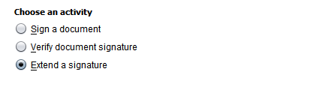
Figure 1: "Choose an activity" panel

This is the main menu, where the user is asked to select which type of operation he/she wants to do, among which:
- Sign a document: allows the user to choose a document and produce a cross-border compatible electronic signature of its contents, using a compatible hardware or software token;
- Verify document signature: allows the user to analyse an already existing file, and generate a detailed validation report containing information on the electronic signature(s) found in it, particularly assessing their trustworthiness and qualifications;
- Extend a signature: allows the user to enhance an already existing electronic signature by adding advanced properties to it, strengthening it with cross-border interoperability, long-term validity and non-repudiation features.
The next chapters will cover these three use cases in detail.
To begin an activity, simply select the corresponding radio button and click the “Next” button at the bottom. While following the wizard steps, the “Next” button moves to the next step, the “Previous” button reverts to the previous step. A disabled button means the function is not available, e.g. the input on the current screen is not properly filled in, or this is already the last/first step.
At any time, clicking the “Cancel” button takes the user back to the “Choose an activity” main menu.

Signing a Document

Choosing the Document to Sign
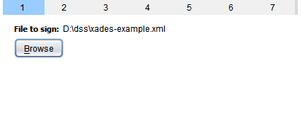
Figure 2: File to sign selection panel

This panel lets the user specify the file with the contents to be signed. A file has to be selected in order to be able to continue. The path to the currently selected file is displayed, or “<no file selected>” if no file has been selected yet.
Clicking the “Browse” button opens a file selection dialog:
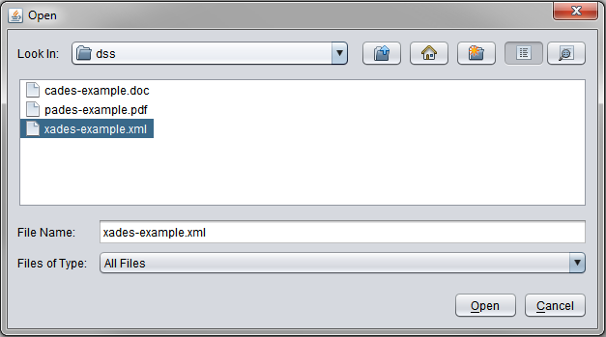
Figure 3: File picker dialog

This dialog displays the local computer file system, and allows navigating inside folders and picking any file. When the desired file has been selected, the “File to sign” label is updated with its path. The user is then allowed to click “Next” and continue with the signature process.

Choosing the Signature Characteristics
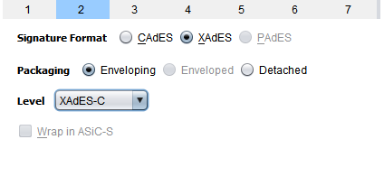
Figure 4: Signature format, packaging, level panel

On this panel, the user is asked to decide the format, packaging, level and wrapping mode of the resulting electronic signatures.

Signature Format
DSS supports signatures in CAdES, XAdES and PAdES formats. The actual formats available depend on the type of file selected in the previous step.
- CAdES is a binary format and is available for any file, regardless of its type;
- XAdES is a XML signature and is available for any file, regardless of its type;
- PAdES is a PDF signature and is therefore only available for PDF files.

Signature Packaging
The packaging of a signature is the way it is related with the content being signed.
- Enveloping means that the signature object itself will contain the actual signed content. This packaging is available for CAdES and XAdES;
- Enveloped means that the signature will be added to the file, apart from the actual signed content. This packaging is available for PAdES when signing PDF document and XAdES when signing XML files.
- Detached means that the signature will be stored as a separate file from the one containing the signed content. The original file is therefore not altered, but both files are to be provided to be considered a complete electronically signed document. This packaging is available for CAdES and XAdES.

Signature Level
The level of the signature is a representation of its “durability”: the higher the level, the more features and properties it contains for long-term validation, non-repudiation, etc…
DSS supports all signature levels as defined in ETSI specifications ([R04], [R05] and [R06]).

Wrap in ASiC-S
This option is only available for detached CAdES signatures.
It allows to create a specially crafted Zip file for packaging the actual unaltered document and its CAdES PKCS#7 signature file in one container, following the ASiC-S specification [R15].

Providing the Signature Token
The next few panels allow selecting the digital ID (i.e., private key and certificate) which will be used for signing. This digital ID may be stored either in various formats and devices.

Selecting the Signature Token API
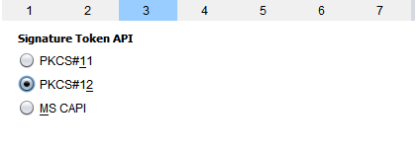
Figure 5: Signature Token API panel
DSS can use several interfaces to interact with the desired SSCD:
- PKCS#11 is a standard interface standard for cryptographic tokens, usually used to access SSCDs such as smart cards – it requires a previously installed driver for the tokens and/or the reader hardware;
- PKCS#12 is a file format to store tokens in an encrypted, password-protected file;
- MS CAPI (Microsoft CryptoAPI) is an interface for accessing tokens through the Microsoft Windows cryptography subsystem, and is therefore only available when the applet is run under this operating system.

Using PKCS#11
After choosing “PKCS#11” as the Signature Token API and clicking “Next”, the user is presented with the following screen:
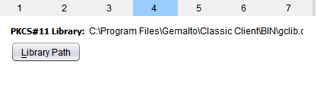
Figure 6: PKCS#11 library selection panel

On this panel, the correct PKCS#11 software library for accessing the desired token has to be selected. The path to the PKCS#11 library is saved in the user preferences. The library may be selected by clicking on the “Browse” button, and navigating to the location of the library file. The location of this library depends on the signature token, operating system, installation configuration; in most cases, it will be a .dll file on Windows systems, or a .so file on UNIX systems. When in doubt, the user should contact the CSP which issued the token for more information and support.
Next time the user connects to DSS/Web, the library path field will be already filled.
The process of file selection is similar to 2.3.1 - Choosing the Document to Sign.
Note: Before clicking “Next” at this point, the token (e.g. SSCD) has to be connected to the workstation: for example, the smart card has to be inserted into the reader. The PKCS#11 library may display graphical interface elements, such as popup dialogs, to require additional information from the user, e.g. a PIN code. The actual graphical interface elements depend on the library being used.

Using PKCS#12
After choosing “PKCS#11” as the Signature Token API and clicking “Next”, the user is presented with the following screen:
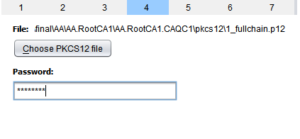
Figure 7: PKCS#12 file selection and password input panel

On this panel, the correct PKCS#12 file containing the desired Signature Token may be selected. Clicking the “Choose PKCS12 file” button opens the standard file selection dialog. The process of file selection is similar to 2.3.1 - Choosing the Document to Sign.
Most of the time, the PKCS#12 file is encrypted and protected by a password: the correct password must be entered in the text box.

Using MS CAPI
After choosing “MS CAPI” as the Signature Token API and clicking “Next”, there is no particular information to provide: the user is directly taken to the next step. The list of Digital IDs to choose from will be those known to Windows in the user’s Personal Store – provided that the necessary software and hardware have been properly configured. When in doubt, the user should contact the CSP which issued the token for more information and support.
Note: Before clicking “Next” at this point, the token (e.g. SSCD) has to be connected to the workstation: for example, the smart card has to be inserted into the reader. Windows’ CryptoAPI, or the SSCD driver, may display graphical interface elements, such as popup dialogs, to require additional information from the user, e.g. a PIN code. The actual graphical interface elements depend on the token being used.

Choosing the Signing Certificate
After the Signature Token API has been initialised, the “Choose the signing certificate” panel displays the Digital IDs that have been found in the token:
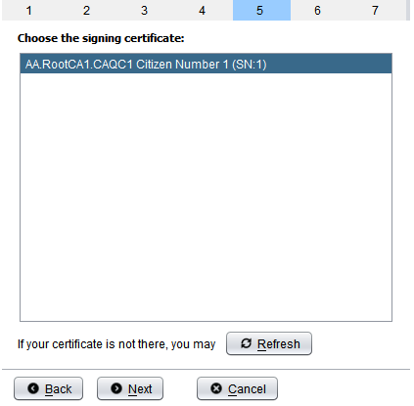
Figure 8: Signing certification selection panel

The list box contains entries with the Common Name and serial number of all certificates available for signing. If the desired certificate/digital ID is not listed, the user may click the “Refresh” button after verifying hardware connections and software configurations.
When the correct certificate has been selected, the user can click “Next” to go to the next step.
Note: There might be token-specific graphical interface elements being displayed at this point.

Supplying Additional Extended Signature Properties
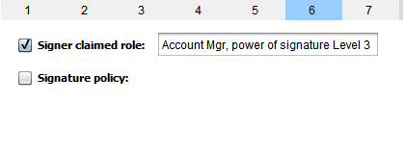
Figure 9: Additional extended signature properties panel

This panel’s purpose is to let the user specify additional optional information that will be included with the signature. The actual information that may be selected depends on the signature’s format and level.

Signer Claimed Role
If the user has a specific role(s) he/she claims would be relevant to include in the signature (for instance, his/her position within an organisation), it is possible to do so by checking the “Signer Claimed Role” check box and providing some value in the text box. This is optional, and there is no constraint on the value set for the role.
The relevance of specifying claimed roles depends on the situation and is left to the discretion of the user.

Signature Policy
If the user has information about the signature policy and wants to apply it to the signature, checking the “Signature policy” check box serves this purpose.
Note: Failure to include a proper signature policy will prevent the signature from reaching the EPES level.
A signature policy may be either implicitly inferred from the certificate/token that was used for its creation, it this case, setting the “Implicit” mode is sufficient. In other cases, it might be required to explicitly include an unambiguous policy object identifier and/or a hash value of the signature policy (likely to be provided by the CSP, or otherwise known if there is an explicit need for a signature policy); setting the “Explicit” mode allows to input this information, namely:
- The Policy OID as a dot-separated digits string;
- The hash value of the signature policy in Base-64 format, along with the algorithm that was used to produce it (SHA1 is the only allowed option at this time).
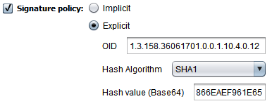
Figure 10: Specifying an explicit signature policy

The relevance of specifying information about a signature policy depends on the situation and is left to the discretion of the user.

Selecting the Signed File Location
At this last step, the user is asked to provide the location where the file containing the generated signature will be saved:
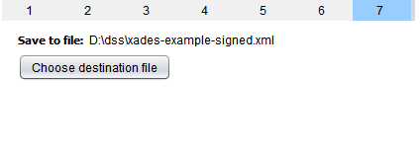
Figure 11: Output signed file selection panel

A default file name is suggested by the applet; it can however be changed by clicking on the “Choose destination file”. The standard file chooser dialog opens. The process of file selection is similar to 2.3.1 - Choosing the Document to Sign.
When done selecting the output file path, every piece of required information is collected: clicking on the “Finish” button begins the actual signature creation.
Note: There might be token-specific graphical interface elements being displayed at this point, asking for PIN codes or passphrases, for the SSCD in use.

Finishing the Signature Generation Process
The signature creation process may take some time.
If the signature has been successfully generated, the following is displayed:
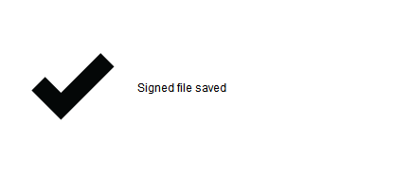
Figure 12: Signature created successfully

If an error occurs, the following screen appears:
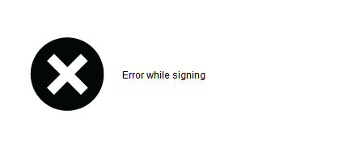
Figure 13: Signature creation failed

Clicking on “Next” or “Cancel” returns to the main menu, and “Back” offers a chance to retry.

Verifying a Document Signature

Selecting the Input
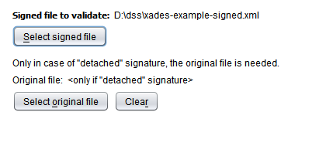
Figure 14: Signed file and content to verify selection panel

This panel lets the user specify the file with the signature(s) to verify. A file has to be selected in order to be able to continue. The path to the currently selected file is displayed, or “<no file selected>” if no file has been selected yet.
Clicking the “Select signed file” button opens a file selection dialog; the process of file selection is similar to 2.3.1 - Choosing the Document to Sign.
This dialog displays the local computer file system, and allows navigating inside folders and picking any file. When the desired file has been selected, the “File to sign” label is updated with its path. The user is then allowed to click “Next” and continue with the signature process.
If the file containing the signature doesn’t also include the content (case of “detached” signatures), the original file has to be provided as well. Clicking on the “Select original file” allows doing so.
The validation process, which may take some time, begins upon clicking on the “Next” button. When finished, the validation report is displayed. If the file cannot be verified for any reason, an error screen is displayed. The user may review the error, click “Previous” and try again.

Viewing the Validation Report
The validation report presents validation results in 3 levels, displayed as tabs:
- Simple Report. This tab summarises the results of the report, providing the status of the validation: Valid, Indeterminate, or Invalid;
- Detailed Report Tree: This tab presents the process of validation and the result of each validation (OK or KO);
- Diagnostic Tree: This tab details the information retrieved from the signature and the certificates.
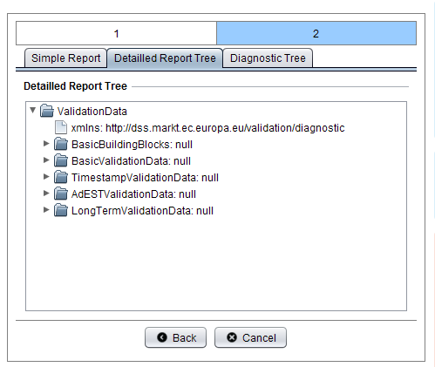
Figure 15: Validation report tree viewer panel

The validation report contains a hierarchical view containing extensive amount information about all the signatures that were found in the provided file.
The following paragraphs explain, node by node, the structure of the validation report.

TimeInformation Node
This node contains the time when the validation was performed.

SignatureInformation Nodes
One SignatureInformation node is displayed for every signature detected in the provided document.
It contains the following sub-nodes:

Signature structure verification
Specifies if the structure of the signature is syntactically correct or not, according to the signature format (CAdES, XAdES or PAdES).

Signature verification
Specifies if the signature is mathematically correct or not.

Signature algorithm
Provides the name of the algorithm applied for the signature. The actual value reported depends on the signature format: for CAdES and PAdES it is the OID of the cipher as found in the CMS structure; for XAdES it is the XMLDSIG URI.

CertPathRevocationAnalysis
This node and its sub nodes contain details about the certificate path validation, including whether or not the end-user certificate has been verified to a trusted list.

Summary
This node contains the result of the certification path validation. May contain a sub node detailing the issue encountered, for instance, “no trusted list service was found”.

Certificate Verification
For every certificate encountered during the certification path verification, a sub node containing the certificate subject name is present. It contains the following sub nodes:
- Issuer name: specifies the name of the certificate’s issuer;
- Serial number: specifies the serial number of the certificate;
- Validity at signing time: specifies whether or not the signing time fits with the validity period of the certificate;
- Signature verification: contains information about the validity of the signature:
  - Signature verification: specifies if the signature is mathematically correct or not;
  - Signature algorithm: provides the name of the algorithm applied for the signature.
- Certificate status: contains information about the result of the certificate revocation verification. This node contains a sub-node named RevocationVerificationResult which may be:
  - Valid;
  - Undetermined (if, for instance, no relevant revocation data could be found nor retrieved);
  - Revoked – in this case, the following sub node will provide additional information about the revocation:
    - Revocation date: if the certificate is revoked, this elements contains the date and time of revocation;
    - Issuer: if the certificate is revoked, specifies the name of the issuer of the revocation data;
    - Issuing time: if the certificate is revoked, specifies the date and time at which the revocation data has been issued.
    - Revocation time: if the certificate is revoked, specifies the date and the time at which the revocation has occurred.

Trusted List Information
This node contains information about the Trust Service Provider and Trusted Service related to the signer certificate which was eventually found in one of the loaded Trusted Lists.
- Service was found: specifies if a corresponding service has been found in a trusted list during the validation algorithm;
- Trusted list well signed: determines if the trusted list in question contains a valid, trustworthy signature;

The following nodes appear only if the service was found:

- TSP Name: specifies the name of the service provider, extracted from the trusted list;
- TSP Trade name: specifies the trade name of the service provider, extracted from the trusted list;
- TSP Postal address: specifies the postal address of the service provider, extracted from the trusted list;
- TSP Electronic address: specifies the electronic address of the service provider, extracted from the trusted list;
- Service type identifier: specifies the service type identifier of the corresponding service, extracted from the trusted list;
- Service Name: specifies the name of the corresponding service, extracted from the trusted list;
- Current status: specifies the current status of the corresponding service, extracted from the trusted list;
- Current status starting date: specifies the current status starting date of the corresponding service, extracted from the trusted list;
- Status at reference time: specifies the status of the service at the reference time of the validation algorithm, extracted from the trusted list;
- Status starting date at reference time: specifies the status starting date of the corresponding service at the reference time of the validation algorithm, extracted from the trusted list;
- Qualification element: if present, specifies the qualifier properties related to the certificate, extracted from the trusted list. In this case, it contains a QualificationElement node containing:
  - One or several URIs of the Trust Service status as defined by ETSI;
  - A CompositeCriteriaList sub node containing:
    - A Composition node containing the type of composition for the criteria, i.e. “atLeastOne”, “all” or “none”.
    - A Criteria List sub node containing a list of conditions (KeyUsageCondition or PolicyIdCondition) that had to be respected by the signer certificate in order to assign the qualifier(s) to it. Note: those conditions were indeed verified, or the qualifier(s) wouldn’t appear at all in the report.

SignatureLevelAnalysis

Signature Format
Specifies the format of the signature:
- XAdES;
- CadES;
- PAdES.

SignatureLevelBES
Contains the information related to the BES level of a signature; the icon of the node itself specifies whether the signature has reached the BES level or not; it also contains the following sub nodes:
- Certificates: contains the list of X509 certificates included in the signature;
- Signing certificate: specifies, if present, the signing certificate reported by its reference in the “Signing certificate” attribute contained in the signature;
- Signing Time: specifies the reported time of the signature generation;
- Mime type: specifies the data format of the signed document;
- Location: if present, contains information about the place where the signature was generated;
- Signer role: if present, specifies the claimed role of the signer;
- Counter signature: if present, contains the result of the verification of a counter signature:
  - Signature verification: specifies if the signature is mathematically correct or not;
  - Signature algorithm: provides the name of the algorithm applied for the signature.
- Time stamp: if present, specifies the result of the verification of the content time stamp(s). Contains a TimeStampVerificationResult node for each timestamp that was found, with the following information:
  - Serial number: Contains the serial number of the timestamp;
  - Creation time: Contains the secure time when the timestamp was generated;
  - Issuer name: Contains the subject name of the timestamp authority’s certificate;
  - Signature verification: Specifies whether the signature of the timestamp was mathematically correct;
  - Signature algorithm: contains the OID of the cipher used to produce the timestamp;
  - Certificate path verification: indicates whether the certificate path of the time stamp has been verified up to a trusted list.

SignatureLevelEPES
Contains the information related to the EPES level of a signature; the icon of the node itself specifies whether the signature has reached the EPES level or not; in that case, it also contains the following sub nodes:
- Signature policy identifier: specifies the policy OID under which the signature has been produced if it is explicit or displays the label “IMPLICIT” if the policy is implicit.

SignatureLevelT
Contains the information related to the T level of a signature; the icon of the node itself specifies whether the signature has reached the T level or not; it also contains the following sub nodes:
- Signature time stamp: specifies the result of the verification of the signature timestamp(s). Contains a TimeStampVerificationResult node for each timestamp that was found, with the following information:
  - Serial number: Contains the serial number of the timestamp;
  - Creation time: Contains the secure time when the timestamp was generated;
  - Issuer name: Contains the subject name of the timestamp authority’s certificate;
  - Signature verification: Specifies whether the signature of the timestamp was mathematically correct;
  - Signature algorithm: contains the OID of the cipher used to produce the timestamp;
  - Certificate path verification: indicates whether the certificate path of the time stamp has been verified up to a trusted list.

SignatureLevelC
Contains the information related to the C level of a signature; the icon of the node itself specifies whether the signature has reached the C level or not; it also contains the following sub nodes:
- Certificate references verification: specifies whether the certificate references match the certificates from the certification path or not;
- Revocation references verification: Specifies whether the present revocation references match the revocation data from the certification path or not.
Each of those nodes may also contain additional information beneath in case of an issue.

SignatureLevelX
Contains the information related to the X level of a signature; the icon of the node itself specifies whether the signature has reached the X level or not; in that case, it also contains the following sub nodes:
- Signature and references time stamp: if present, specifies the result of the verification of the time stamp(s). Contains a TimeStampVerificationResult node for each timestamp that was found, with the following information:
  - Serial number: Contains the serial number of the timestamp;
  - Creation time: Contains the secure time when the timestamp was generated;
  - Issuer name: Contains the subject name of the timestamp authority’s certificate;
  - Signature verification: Specifies whether the signature of the timestamp was mathematically correct;
  - Signature algorithm: contains the OID of the cipher used to produce the timestamp;
  - Certificate path verification: indicates whether the certificate path of the time stamp has been verified up to a trusted list.

SignatureLevelXL
Contains the information related to the XL (X “Long”) level of a signature; the icon of the node itself specifies whether the signature has reached the XL level or not; it also contains the following sub nodes:
- Certificate values verification: specifies whether or not the present certificate values match the certificate references present in the C Level;
- Revocation values verification: specifies whether or not the present revocation values match the revocation references present in the C Level.

SignatureLevelA
Contains the information related to the A level of a signature; the icon of the node itself specifies whether the signature has reached the A level or not (meaning that it contains at least one archive timestamp); in that case, it also contains the following sub nodes:
- Archive time stamp verification: if present, specifies the result of the verification of the archive time stamp(s). Contains a TimeStampVerificationResult node for each timestamp that was found in order, with the following information:
  - Serial number: Contains the serial number of the timestamp;
  - Creation time: Contains the secure time when the timestamp was generated;
  - Issuer name: Contains the subject name of the timestamp authority’s certificate;
  - Signature verification: Specifies whether the signature of the timestamp was mathematically correct;
  - Signature algorithm: contains the OID of the cipher used to produce the timestamp;
  - Certificate path verification: indicates whether the certificate path of the time stamp has been verified up to a trusted list.

SignatureLevelLTV
Contains the information related to the LTV level of a (PAdES) signature; the icon of the node itself specifies whether the signature has reached the LTV level or not; in that case, it also contains the following sub nodes:
- Certificate values verification: specifies whether the certificate values present in the security store match the certificates of the certification path or not;
- Revocation values verification: specifies whether the revocation values present in the security store match the revocation data of the certification path or not.

QualificationsVerification
If the qualification elements are present, this node contains the qualification information:
- QCWithSSCD: specifies whether the matching criteria for QCWithSSCD are reached by the signing certificate or not.
- QCNoSSCD: specifies whether the matching criteria for QCNoSSCD are reached by the signing certificate or not.
- QCSSCDStatusAsInCert: specifies whether the matching criteria for QCSSCDStatusAsInCert are reached by the signing certificate or not.
- QCForLegalPerson: specifies whether the matching criteria for QCForLegalPerson are reached by the signing certificate or not.

QCStatementInformation
Contains the result of the QC statement verification:
- QCP presence: specifies if the ETSI defined QCP OID is present;
- QCP+ presence: specifies if the ETSI defined QCP+ OID is present;
- QcCompliance presence: specifies if the QcCompliance statement is present;
- QcSSCD presence: specifies if the QcSSCD statement is present.

Final Conclusion
Specifies if the signature is QES, AdES_{QC} or AdES.
The final conclusion of the validation report must determine whether or not the end-entity certificate is qualified and if the signature is AdES, AdES_{qc} or QES. This conclusion is inferred from both trusted list analysis and certificate content analysis. The following table describes the possible conclusions of the validation algorithm.
1=QES  2=AdES_{QC}  3=AdES | *=no TL confirmation from MS where CSP/CA is established  **=no TL confirmation as MS TL where CSP/CA is established is not available  ***=TL confirmation but TL not signed or TL verification cert not in LOTL | Certificate content
  indicates a conflict between certificate content and Trusted List content
  Strictly speaking a cert with QcSSCD only (no QcC statement set) should not
  be considered as a QC
1=QES  2=AdES_{QC}  3=AdES |  | QCP only | QCP  + QcC | QCP  + QcC  +QcSSCD | QCP+ only | QCP+  + QcC | QCP+  + QcC  +QcSSCD | QcC only | QcSSCD  only | QcC  + QcSSCD | No machine processable info (+) | QCP+  + QcC  +QcSSCD  +QCP
TL content | Cert covered by CA/QC | 2 | 2 | 1 | 1 | 1 | 1 | 2 | 3 | 1 | 3 | 1
TL content | Cert covered by CA/QC  + QCWithSSCD | 1 | 1 | 1 | 1 | 1 | 1 | 1 | 3 | 1 | 3 | 1
TL content | Cert covered by CA/QC  + QCNoSSCD | 2 | 2 | 2 | 2 | 2 | 2 | 2 | 3 | 2 | 3 | 2
TL content | Cert covered by CA/QC  + QCSSCDAsInCert | 2 | 2 | 1 | 1 | 1 | 1 | 2 | 3 | 1 | 3 | 1
TL content | Cert covered by CA/QC  + QCForLegalPerson | 2 | 2 | 1 | 1 | 1 | 1 | 2 | 3 | 1 | 3 | 1
TL content | Cert not covered by CA/QC | 2* | 2* | 1* | 1* | 1* | 1* | 2* | 3* | 1* | 3* | 1*
TL content | Trusted List not available | 2** | 2** | 1** | 1** | 1** | 1** | 2** | 3** | 1** | 3** | 1**
TL content | TL available but not signed or TL verification cert not in LOTL | 2*** | 2*** | 1*** | 1*** | 1*** | 1*** | 2*** | 3*** | 1*** | 3*** | 1***
Table 5: Final conclusion matrix

Extending a Previously Created Signature
DSS is able to extend AdES-BES/EPES CMS, PDF or XML signatures to the desired AdES (T, C, X, XL, A, LTV) level, by adding level-specific attributes and properties; these structures are not signed by the original signer, therefore making it possible to extend any signature to an advanced, cross-border operable and long-term verifiable fashion – even those who weren’t created by the user, and without the need to the original signature token.

Selecting the Signature to Extend
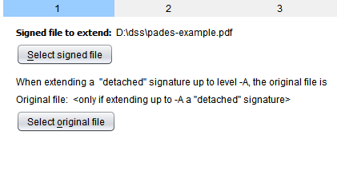
Figure 16: Signed file to extend and content selection panel

This panel lets the user specify the file containing the signature(s) to extend. A file has to be selected in order to be able to continue. The path to the currently selected file is displayed, or “<no file selected>” if no file has been selected yet.
Clicking the “Select signed file” button opens a file selection dialog. The process of file selection is similar to 2.3.1 - Choosing the Document to Sign.
Extending a signature to the –A level implies generating a so-called archive timestamp which securely applies time to, among other things, the original content. Therefore, in this case and when the content is detached from the signed file (“detached signature” scenario), it has to be provided in order to be part of the timestamped digest. If this scenario applies to the upcoming extension process, the original file can be specified in the same way as the signed file by clicking on the “Select original button”. Failure to provide the original content when attempting to extend a detached signature to the –A level will result in an error during the actual extension.

Selecting the Target Level
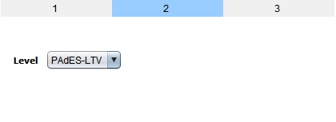
Figure 17: Target level selection panel
This panel contains a combobox for selecting the new level to be reached by the signature(s). Simply select the desired level, which depends on the detected file format, and then click “Next”.
Note: If a signature already has reached the specified level, it will remain as is.

Note: If a file with multiple signatures was provided, every detected signature not reaching the target level will be extended.

Selecting the Extended File Location
At this last step, the user is asked to provide the location where the file containing the generated signature will be saved:
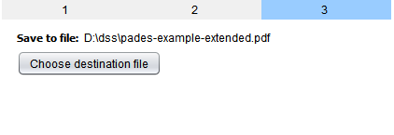
Figure 18: Extended output file selection panel

A default file name is suggested by the applet; it can however be changed by clicking on the “Choose destination file”. The standard file chooser dialog opens. The process of file selection is similar to 2.3.1 - Choosing the Document to Sign.
When done selecting the output file path, every piece of required information is collected: clicking on the “Finish” button begins the actual extension process.

Finishing the Signature Extension Process
The signature extension process may take some time.
The applet reports the success or failure of the operation, in a similar way to the signature creation process.
Clicking on “Next” or “Cancel” returns to the main menu, and “Back” offers a chance to retry.

TLManager

Technical Requirements
The technical requirements to start the TLManager application are:
Technical Requirements
Constraint area | Constraint
Java Runtime Environment | JRE version 1.6 has to be installed in the system.
SSCD Device | A signing device has to be available, if PKCS#11 is to be used.
Table 6: Technical Requirements

TLManager overview
TLManager is a Graphical User Interface (GUI) allowing the management of Trusted Lists. These lists can be:
- Member State Trusted lists;
- List Of Trusted List.
The management of such a list comprises creating, editing, validation and signing.
Depending on the type of list being managed in the tool, a number of parameters are predefined and will automatically fill some information. This information is not shown directly in the GUI (cf. Annex I: Editing modes of TLManager).
According to [R02], the Trusted List must follow predefined business rules. TLManager performs a list of verification in order to ensure that all the rules are respected.
The main screen of TLManager is as follows:
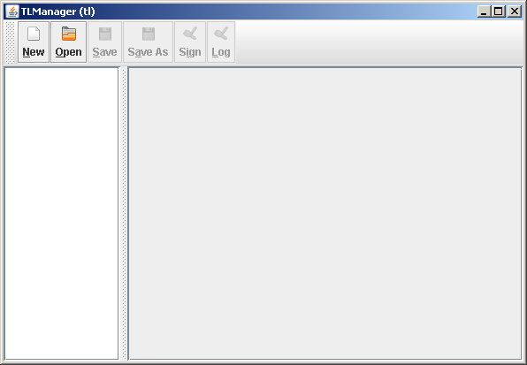
Figure 19: TLManager Main screen

This screen provides access to the main functionalities of the tool:
- New: allows to create a new empty Trusted List;
- Open: allows to open an existing Trusted List;
- Save: allows to save the current Trusted List;
- Save As: allows to save the current Trusted List with a different filename;
- Sign: allows to sign the Trusted List with the validation of business rules;
- Log: displays validation results (if any).

Interface features
Inside TLManager, a Trusted List is structured in different pages grouping logical information. These pages are:
- TSL information page;
- Pointer to other TSL page;
- TSP information page;
- Service current status information page;
- Service information extension page;
- Qualifications page;
- Service status history page.

In order to ease the user experience and to allow the reuse of these components, several interface features are provided:
- Navigation tree: allows to select the different pages of the current Trusted List;
- Colour convention: is used to provide additional information on specific fields;
- Complex types:
  - Multilingual values: this group includes all TL fields that can be provided in several languages. Multilingual fields may contain different information, but one common constraint is that data for English can be structured and contained different information, but the common constraint is the necessity to provide data in English;
  - Multiple values: this group includes fields for which several values can be provided;
- Certificate viewer: this type is used to upload and display information about certificates.

Navigation tree
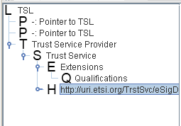
Figure 20: Example of navigation tree

The navigation tree is a classical concept to navigate through a Trusted List. In TLManager, this tree is used in the following ways:
- Left click on a node: show the respective page in the content area to the right;
- Right click on a node: opens a contextual menu, if any. (cf chapter 3.6 - Edit a Trusted List).

Colour convention
According to [R14] most of the fields are mandatory in the Trusted List and must be filled. The verification performed by TLManager checks the presence of these mandatory fields (cf. chapter 3.8.1 - Step 1: Validate the Trusted List).
To help the user to distinguish which fields must be filled, TLManager uses the following colour convention:
- Red label: denotes a mandatory field;
- Black label: denotes an optional field.
In addition, labels of mandatory fields automatically turn black once data has been provided.

Multilingual values
Fields that can be provided in several languages use a specific interface feature that enables the user to add language specific data.
The following button is displayed for such fields:

Figure 21: Multilingual values button

The label behind the button denotes the current number of entries for this field.
Clicking on the “Multilingual values” button opens a dialog that is described in below.

Structure
The interface is composed of:
- A list with all available language codes on the left side;
- A content area to the right, which differs depending on the type of field.
- A close button at the bottom to close the dialog.
To provide a value for a specific language, the language code has to be selected and the content entered.
The following information is available:
- A language for which data is mandatory follows the colour convention, thus is shown in red;
- ‘*’ is shown in front of a language code for which data has been provided.
Data can be introduced or changed in a very straightforward manner without specifically confirming the input. The close button or selection of a different language code confirms the input.
Furthermore, language codes can be duplicated to be able to provide more data for the same language. Right clicking on a language code opens a small context menu that shows just ‘Duplicate’. To distinguish the duplicated language codes, they are prefixed with a ‘_X’, where X is a number. In the resulting xml file, these language codes will be the same as the original one and it does not matter for which of these entries data is provided.
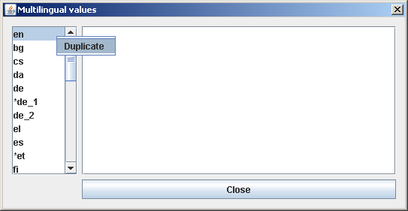
Figure 22: Duplicate a language entry

Available content area for multilingual values
For the content area of a multilingual dialog there are several variations to collect the data.

Multilingual textfield
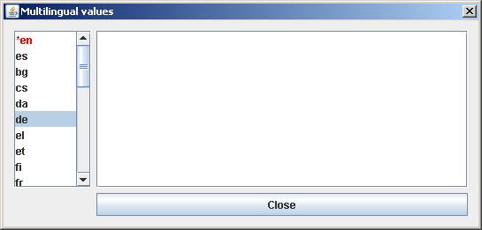
Figure 23: Example of multilingual textfield interface

Multilingual postal address
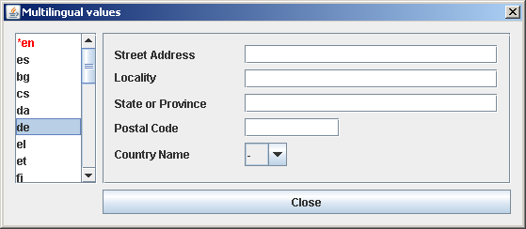
Figure 24: Example of multilingual postal address interface

Multiple values
Multiple values interfaces are used for fields for which a user can provide several values but without any relation to a language.
The following button is displayed for such fields:

Figure 25: Multiple values button

The label behind the button denotes the current number of entries for this field.

Structure
The interface is composed of:
- A list with entries that have been added so far on the left side; the number can be modified with the buttons below:
  - “Add”: creates a new entry;
  - “Remove”: removes the selected entry.
- A content area to the right, which differs depending on the type of field;
- A close button at the bottom to close the dialog.
By default the multiple values interface contains one entry: “Entry 1”. If data has been provided for one entry, the label is suffixed with ‘*’.
Data can be introduced or changed in a very straightforward manner without specifically confirming the input. The close button, the add button or selection of a different entry confirms the input.
Note: The actual name of the entry label in the list on the left side is not important! It just serves as an item to click on and differentiate between data. Even if there are several entries created but data is just provided for one, the superfluous entries are ignored.

Available content area for multiple values
For the content area of a multiple dialog there are several variations to collect the data.

Multiple textfield
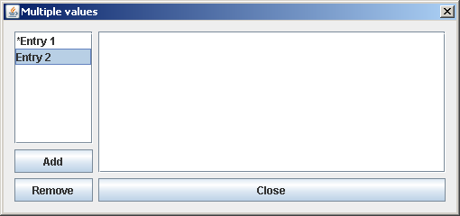
Figure 26: Example of multiple textfield interface

Multiple address
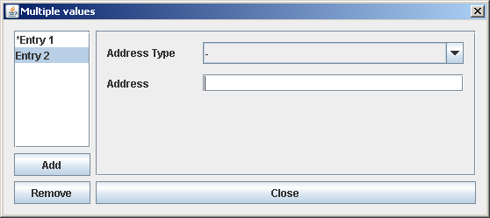
Figure 27: Example of multiple address interface

Multiple selection
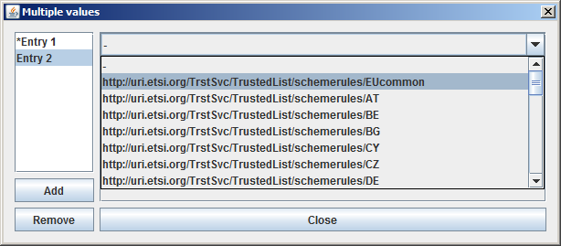
Figure 28: Example of multiple selection interface

Multiple information extension
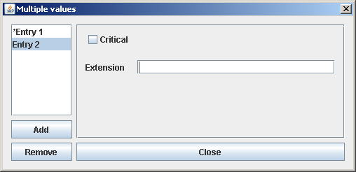
Figure 29: Example of multiple information extension interface

Multiple additional information
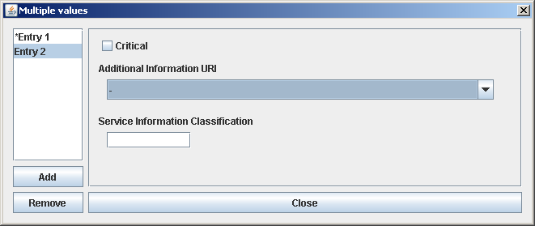
Figure 30: Example of multiple additional information interface

Certificate viewer
TLManager integrates a certificate viewer which is able to:
- Show some of the certificate information;
- Add a certificate to the Trusted List.

Structure
The interface is composed of:
- Subject: The X500PrincipalName of the subject for whom the certicate has been delivered;
- Issues: The X500PrincipalName of the CA that delivered the certificate;
- Serial #: The serial number, attributed by the CA, that identify this certificate;
- Key Usages: The cases for which this certificate can be used.

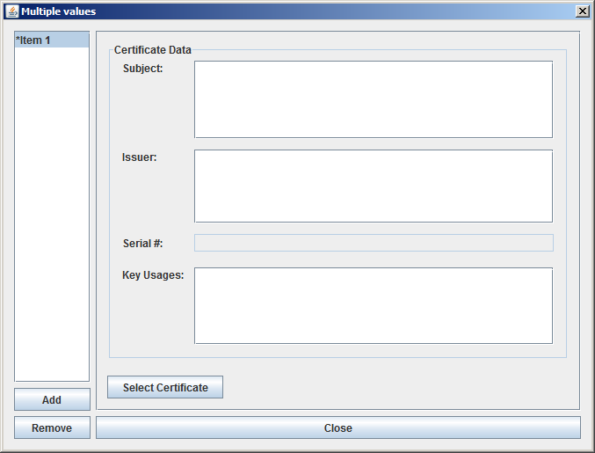
Figure 31: Certificate viewer

All values are filled in automatically when selecting a certificate and cannot be edited manually.
To choose a certificate the “Select Certificate” button is used. It opens a file selection dialog:
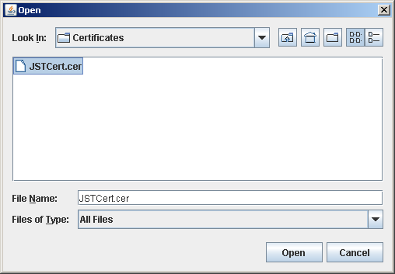
Figure 32: Certificate file selection dialog

Create a new Trusted List
Clicking on the button “New” from the main menu creates a new empty Trusted List:
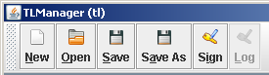
Figure 33: Main menu – New

If the button is clicked when there is already a list opened, a confirmation is asked:
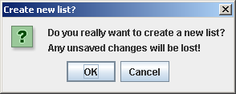
Figure 34: Confirmation dialog
Once created, the new list is ready to be edited (cf. chapter 3.6 - Edit a Trusted List).

Open an existing Trusted List
Clicking on the button “Open” from the main menu opens a file selection dialog:

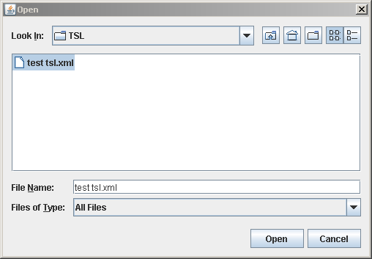
Figure 35: File selection dialog

Invalid TSL
During the opening process, TLManager performs a syntactical verification to check that the proposed file is a valid TSL.
In case of invalid file, the following error is displayed:
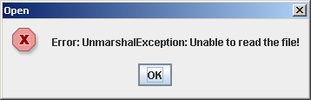
Figure 36: Invalid file error

Furthermore, the ‘TSLType’ of a valid TSL is verified to be in accordance with the current mode of TLManager (cf. [R16] for details).
If the mode is ‘tl’, but the opened list is a LOTL, the following dialog is shown:
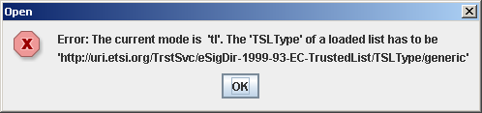
Figure 37: TL expected error

If the mode is ‘lotl’, but the opened list is a TL, the following dialog is shown:
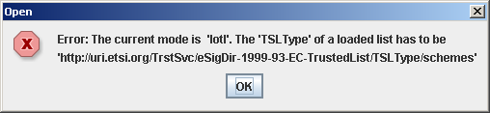
Figure 38: LOTL expected error

Edit a Trusted List
The following table provides an overview over the functionality that is available from the different nodes of the Navigation Tree (cf. chapter 3.3.1 - Navigation tree).
Editing options
Node | Context Menu Options
- TSL | - Add TSP  - Add Pointer  - Sort Tree
- Pointer | - Remove Node
- TSP | - Add Service  - Remove Node
- Service | - Add a Service History  - Add Information Extension  - Remove Node
- History | - Add Information Extension  - Remove Node
- Extension | - Add Qualification Extension  - Remove Node
- Qualification | - Remove Node
Table 7: Editing options

Edit TSL information
The TSL information page is the main page of TLManager and is created by default when a new TSL is created.
This page is available from the navigation tree with a left click on the - Node.
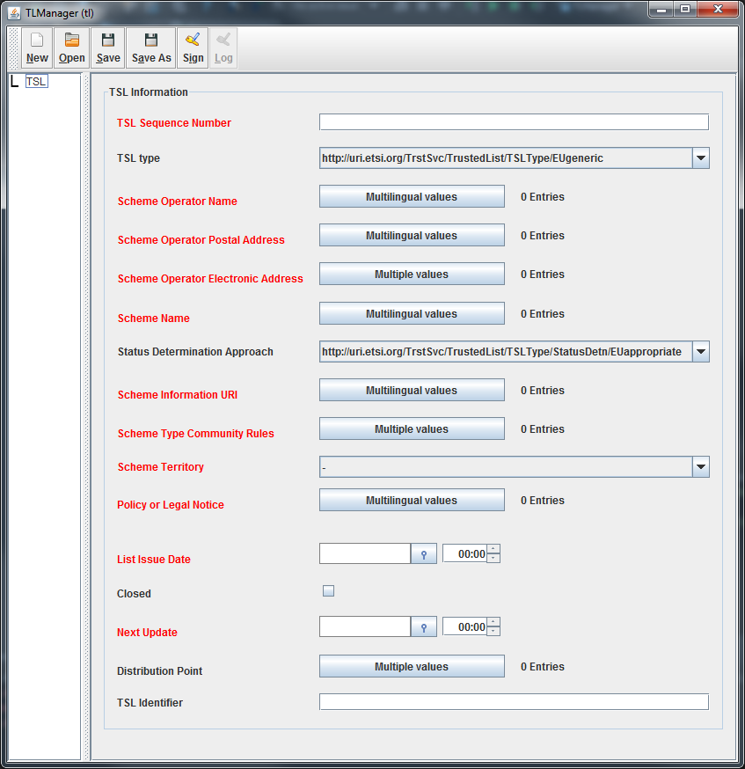
Figure 39: TSL information page

TSL Sequence Number
The sequence number is a numeric textfield. It starts at ”1” for the first release of a TSL.

TSL type
The TSL type is a fixed value for EU member states. Otherwise, it can be freely edited.

Scheme Operator Name
The scheme operator name is the name of the Member State’s body in charge of the TSL.
It can be provided in several languages and uses a Multilingual textfield dialog.

Scheme Operator Postal Address
The scheme operator postal address is the physical address of the scheme operator. It can be provided in several languages and uses a Multilingual postal address dialog.

Scheme Operator Electronic Address
The electronic address of the scheme operator can be an e-mail or a web-site.
Several values can be provided for it and it uses a Multiple address dialog.

Scheme Name
The scheme name is the name used in formal reference to the scheme.
The scheme name must be a string structured as follows:
- CC:name_value
Where
- CC = the ISO 3166-1 alpha-2 Country Code;
- Name_value = the text filled by the user and describing the name of the scheme.

It can be provided in several languages and uses a Multilingual textfield dialog.

Status Determination Approach
The status determination approach is a fixed value for EU member states. Otherwise, it can be freely edited.

Scheme Information URI
The scheme information URI is the path to information describing the general terms and conditions of the scheme.
It can be provided in several languages and uses a Multilingual textfield dialog.

Scheme Type community Rule
The value for scheme type community rule can be a URI that is specific to a LOTL if the current mode of TLManager is ‘lotl’. If the mode is ‘tl’ there have to be 2 URIs.
Several values can be provided for it and it uses a Multiple selection dialog.

Scheme Territory
The scheme territory is a drop down list containing the list of all Member States country codes.

Policy or Legal Notice
The policy or legal notice concerns the legal status of the scheme.
It can be provided in several languages and uses a Multilingual textfield dialog.

List Issue Date
The list issue date is the date and time on which the TSL was issued.
It uses a date and time picker and its time zone is dependant on the system timezone of the computer that runs TLManager.

Closed
If selected, the closed checkbox specifies that the Trusted List is closed. In that case, the field “Next Update” is not available and is automatically set to “Null”.

Next Update
The next update is the last date and time by which the next Trusted List will be issued.
It uses a date and time picker and its time zone is dependant on the system timezone of the computer that runs TLManager.
The difference between list issue date and next update cannot exceed 6 months.

Distribution Point
The distribution point is a URI specifying the location where the current Trusted List is published.
Several values can be provided for it and it uses a Multiple address dialog.

TSL Identifier
The identifier of the Trusted List is an editable textfield.

Add a pointer to other Trusted List
The contextual menu of the “TSL” node allows the creation of a pointer to other TSL.
Right click on the “TSL” to display its contextual menu and click on “Add pointer”.

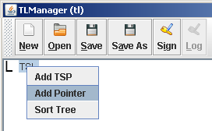
Figure 40: TSL Node contextual menu

A new “Pointer to TSL” node is created in the navigation tree and the “Pointer to other TSL” page is displayed:
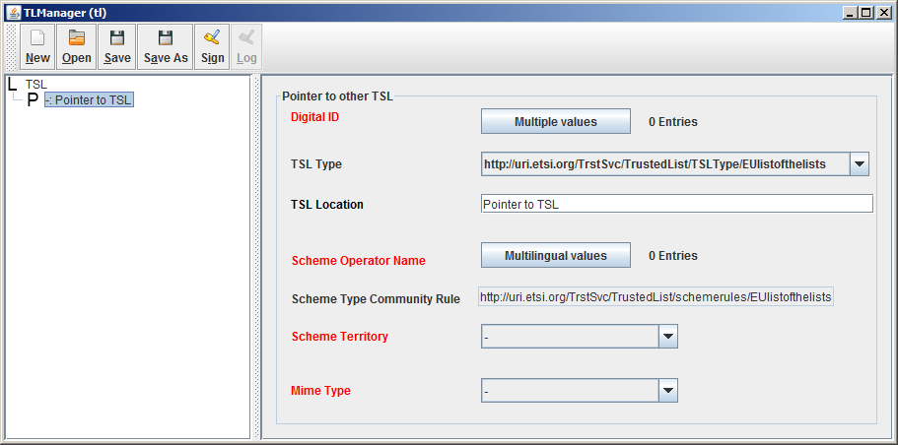
Figure 41: Pointer to other TSL page

Digital ID
The Digital ID is the digital identifier of the issuer of the TSL pointed to.
It is composed of:
- A non-editable textfield containing the subject name of the current uploaded certificate;
- The button “View certificate”: display the Certificate viewer and allows the consultation of the certificate information and the selection of a new certificate;
- The checkboxes “use for TSL”: provide a choice of certificate information to include in the Trusted List. The choices are:
  - Certificate: specify that the entire certificate will be included in the TSL. This option is selected by default and cannot be changed;
  - SubjectName: allow the user to add the subject of the certificate in addition to the entire certificate;
  - SKI: allow the user to add the SKI certificate (if available in the certificate) in addition to the entire certificate.

TSL Type
The TSL type is a fixed value for EU member states. Otherwise, it can be freely edited.

TSL location
TSL location is a pointer to the location of the Trusted List. It uses an editable textfield.

Scheme operator Name
The name of the scheme operator of the Trusted List pointed to. Cf. chapter 3.6.1.3 - Scheme Operator Name.

Scheme Type Community Rule
The scheme type community rule of the Trusted List pointed to.
The scheme type community rule of a pointer to other TSL is automatically deduced from the information provided in the “TSL information” page. Cf. chapter 3.6.1.9 - Scheme Type community Rule.

Scheme Territory
The scheme territory of the Trusted List pointed to. Cf. chapter 3.6.1.10 - Scheme Territory.

Mime Type
The mime type specifies the used media type of the pointed TSL.
It uses a drop down list with the following choices:
- application/pdf
- application/vnd.etsi.tsl+xml

Add a Trusted Service Provider
The contextual menu of the “TSL” node allows the creation of a Trusted Service Provider.
Right click on the “TSL” to display its contextual menu and click on “Add TSP”.

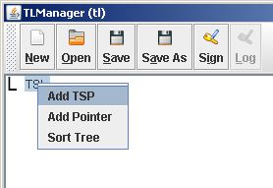
Figure 42: TSL Node contextual menu
By definition, if a Trusted Service Provider is present in the Trusted List, it must mention at least one Trust Service.
For this reason, clicking on “Add TSP” has two effects:
- A new “Trust Service Provider” node is created in the navigation tree;
- A new “Trusted Service“ node is created under the new “Trusted Service Provider” node and the “Service current status information” page is displayed (cf. chapter 3.6.4 - Add a service to a Trusted Service Provider).
Clicking on the “Trusted Service provider” node displays the “TSP information” page:
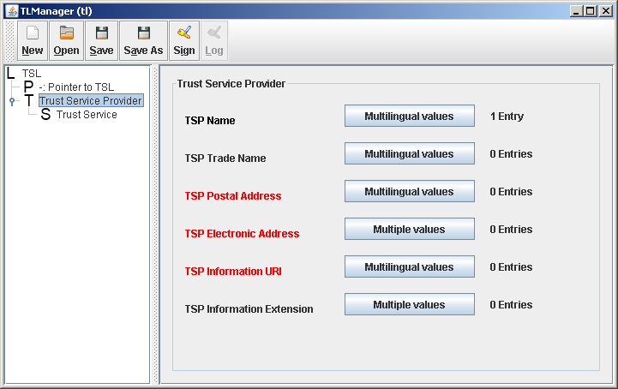
Figure 43: TSP information page

TSP Name
TSP name specifies the name of the legal entity responsible for the TSP services that are or were recognized by the scheme.
It can be provided in several languages and uses a Multilingual textfield dialog.

TSP Trade Name
TSP trade name is an alternative name under which the TSP identifies itself.
It can be provided in several languages and uses a Multilingual textfield dialog.

TSP Postal Address
The TSP postal address is the physical address of the legal entity.
It can be provided in several languages and uses a Multilingual postal address dialog.

TSP Electronic Address
The electronic address of the legal entity could be an e-mail or a web-site.
Several values can be provided for it and it uses a Multiple address dialog.

TSP Information URI
TSP information URI provides a path where users can obtain TSP-specific information.
It can be provided in several languages and uses a Multilingual textfield dialog.

TSP Information Extension
TSP information extension allows a scheme operator to provide specific TSP-related information.
Several values can be provided for it and it uses a Multiple information extension dialog.

Add a service to a Trusted Service Provider
By default, adding a new TSP to the Trusted List induce the creation of a Trust Service related to this TSP. (cf. chapter 3.6.3 - Add a Trusted Service Provider).
In addition, the contextual menu of the “Trusted Service Provider” node allows the creation of a Trust Service.
Right click on the “Trusted Service provider” node to display its contextual menu and click on “Add Service”.
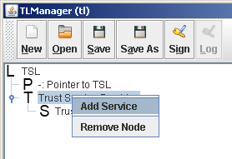
Figure 44:"Trusted Service Provider" Node contextual menu

A new “Trust Service” node is created in the navigation tree and the “Service current status information” page is displayed:
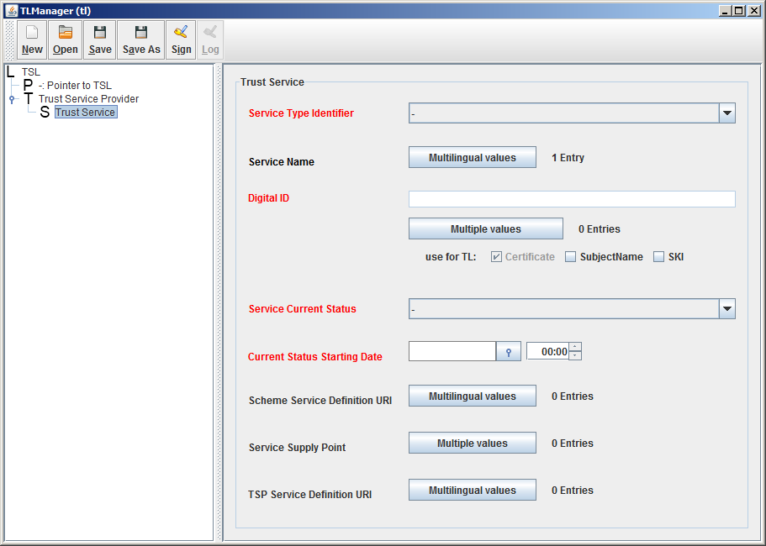
Figure 45: Service current status information page

Service Type Identifier
Service type identifier specifies the identifier of the service type.
It uses a drop down list with the following choices:
- http://uri.etsi.org/TrstSvc/Svctype/CA/PKC
- http://uri.etsi.org/TrstSvc/Svctype/CA/QC
- http://uri.etsi.org/TrstSvc/Svctype/TSA
- http://uri.etsi.org/TrstSvc/Svctype/TSA/QTST
- http://uri.etsi.org/TrstSvc/Svctype/TSA/TSS-QC
- http://uri.etsi.org/TrstSvc/Svctype/TSA/TSS-AdESQCandQES
- http://uri.etsi.org/TrstSvc/Svctype/Certstatus/OCSP
- http://uri.etsi.org/TrstSvc/Svctype/Certstatus/OCSP/QC
- http://uri.etsi.org/TrstSvc/Svctype/Certstatus/CRL
- http://uri.etsi.org/TrstSvc/Svctype/Certstatus/CRL/QC
- http://uri.etsi.org/TrstSvc/Svctype/RA
- http://uri.etsi.org/TrstSvc/Svctype/RA/nothavingPKIid
- http://uri.etsi.org/TrstSvc/Svctype/ACA
- http://uri.etsi.org/TrstSvc/Svctype/SignaturePolicyAuthority
- http://uri.etsi.org/TrstSvc/Svctype/NationalRootCA-QC
- http://uri.etsi.org/TrstSvc/Svctype/Archiv
- http://uri.etsi.org/TrstSvc/Svctype/REM
- http://uri.etsi.org/TrstSvc/Svctype/EDS
- http://uri.etsi.org/TrstSvc/Svctype/EDS/Q
- http://uri.etsi.org/TrstSvc/Svctype/PSES
- http://uri.etsi.org/TrstSvc/Svctype/PSES/Q
- http://uri.etsi.org/TrstSvc/Svctype/IdV
- http://uri.etsi.org/TrstSvc/Svctype/KEscrow
- http://uri.etsi.org/TrstSvc/Svctype/PPwd
- http://uri.etsi.org/TrstSvd/Svctype/TLIssuer
- http://uri.etsi.org/TrstSvc/Svctype/unspecified

Service Name
The service name is the name under which the TSP provides the service.
It can be provided in several languages and uses a Multilingual textfield dialog.

Digital ID
The digital ID specifies the digital identifier unique to the service whose type is specified in “Service type identifier”.
It is composed of:
- A non-editable textfield containing the subject name of the current uploaded certificate;
- The button “View certificate”: display the Certificate viewer and and allows the consultation of the certificate information and the selection of a new certificate;
- The checkboxes “Uses for TSL”: provide a choice of certificate information to include in the Trusted List. The choices are:
  - Certificate: specify that the entire certificate will be included in the TSL. This option is selected by default and cannot be changed;
  - SubjectName: allow the user to add the subject of the certificate in addition to the entire certificate;
  - SKI: allow the user to add the SKI of the certificate (if present in the certificate) in addition to the entire certificate.

Service Current Status
The service current status specifies the identifier of the status of the service.
It uses a drop down list with the following choices:
- http://uri.etsi.org/TrstSvc/TrustedList/Svcstatus/undersupervision
- http://uri.etsi.org/TrstSvc/TrustedList/Svcstatus/supervisionincessation
- http://uri.etsi.org/TrstSvc/TrustedList/Svcstatus/supervisionceased
- http://uri.etsi.org/TrstSvc/TrustedList/Svcstatus/supervisionrevoked
- http://uri.etsi.org/TrstSvc/TrustedList/Svcstatus/accredited
- http://uri.etsi.org/TrstSvc/TrustedList/Svcstatus/accreditationceased
- http://uri.etsi.org/TrstSvc/TrustedList/Svcstatus/accreditationrevoked

Current status Starting Date
The date and time on which the current approval status became effective.
It uses a date and time picker and its time zone is dependant on the system timezone of the computer that runs TLManager.

Scheme Service Definition URI
Specifies where relying parties can obtain service-specific information provided by the scheme operator.
It can be provided in several languages and uses a Multilingual textfield dialog.

Service Supply Point
Specifies where relying parties can access the service.
Several values can be provided for it and it uses a Multiple address dialog.

TSP Service Definition URI
TSP service definition URI specifies where relying parties can obtain service-specific information provided by the TSP.
It can be provided in several languages and uses a Multilingual textfield dialog.

Add a service information extension
The contextual menu of the “Trust Service” node allows the creation of a service information extension.
Right click on the “Trust Service” node to display its contextual menu and click on “Add Information Extension”.
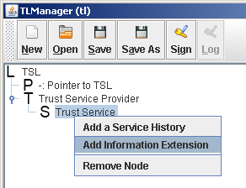
Figure 46: "Trust Service" node contextual menu

A new “Extensions” node is created in the navigation tree and the “Service information extension” page is displayed:
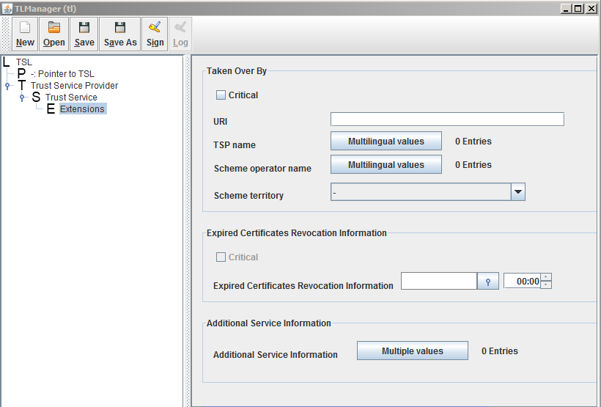
Figure 47: Service information extension page

Note: Only one Service information extension can be added to a Trust Service.

Taken over by
The “Taken over by” extension is used when a Trust Service that was formerly under the legal responsibility of a TSP is taken over by another TSP.
It is composed of:
- Critical: checkbox to specify the criticality of the extension
- URI: editable textfield for a URI pointing towards a descriptive text which informs the user about which entity is currently responsible for the service;
- TSP Name: the name of the new legal entity responsible for the service. Cf. chapter 3.6.3.1 - TSP Name.
- Scheme Operator Name: the name of the Member State’s body in charge of the TSL. Cf. chapter 3.6.1.3 - Scheme Operator Name.
- Scheme Territory: drop down list containing the list of all Member States country codes.

Expired Certificates Revocation Information
Expired certificates revocation information extension indicates that the scope of each CRL and OCSP response, issued by the service on which this extension applies, is extended to include the revocation status of certificates that expired at the exact time specified in the extension or after that time.
It is composed of:
- Expired Certificates Revocation Information: a date and time picker and its time zone is dependant on the system timezone of the computer that runs TLManager.

Additional Service Information
This extension is used to provide additional information about a service.
Several values can be provided for it and it uses a Multiple additional information dialog.

Add a qualification extension
The qualification extension allows the addition of information when specific criteria is required to fully qualify a CA service and/or part of all the certificates it issues.
The contextual menu of the “Extensions” node allows the creation of a qualification extension.
Right click on the “Extensions” node to display its contextual menu and click on “Add Qualification Extension”.
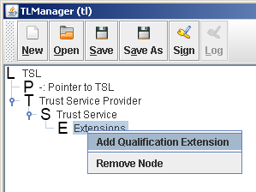
Figure 48: "Extensions" node contextual menu

A new “Qualifications” node is created in the navigation tree and the “Qualification” page is displayed:
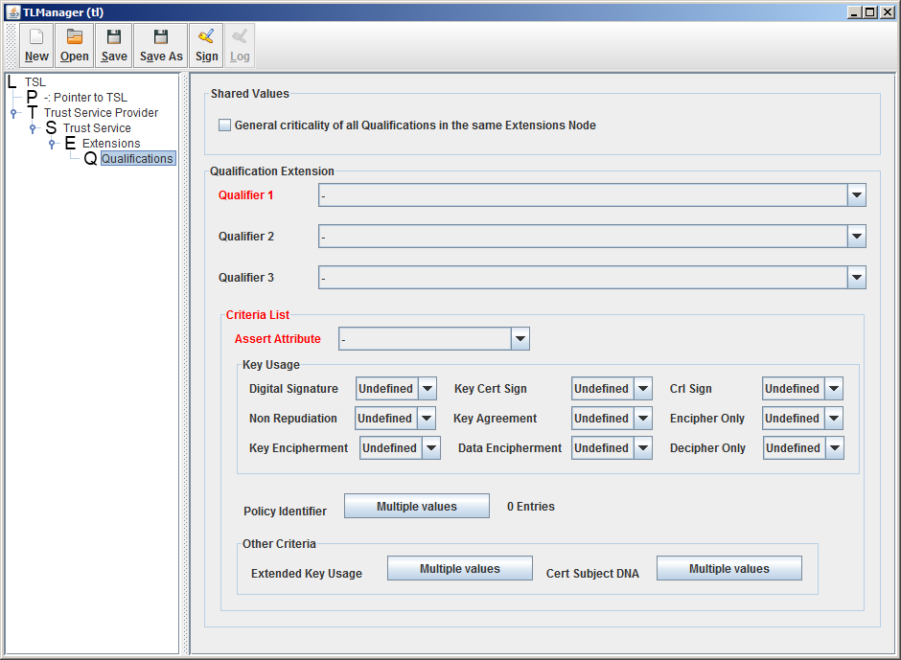
Figure 49: Qualification page

There is no restriction on the number of qualification extensions under a service information extension. However, under the same service information extension, the criticality of all the qualifications has the same value.
For this reason a shared checkbox is used:
- General criticality of all qualifications in the same Extensions node.
The qualification extension is composed of:
- Qualifier 1: drop down list containing the available qualifiers:
  - QCWithSSCD: ensured that any qualified certificate issued under the service and matching the extension’s criteria is supported by a SSCD;
  - QCNoSSCD: ensured that any qualified certificate issued under the service and matching the extension’s criteria is not supported by a SSCD;
  - QCSSCDAsInCert: ensured that any qualified certificate issued under the service and matching the extension’s criteria shall contain the machine-processable information indicating whether or not it is supported by a SSCD;
  - QCForLegalPerson: ensured that any qualified certificate issued under the service and matching the extension’s criteria is issued for legal person;
- Qualifier 2: drop down list with a second qualifier that can be optionally combined with the qualifier 1:
  - QCForLegalPerson;
- Qualifier 3: drop down list with a third qualifier that can be optionally combined with the qualifiers 1 and 2:
  - QCStatement;
- Assert Attribute: Drop down list with the available matching criteria indicators applied to the selected criteria:
  - All: if all assertion must be met;
  - AtLeastOne: if at least one of the assertion must be met;
  - None: if all the assertion must not be met;
- Criteria List: provides the available criteria available:
  - Key Usage: values to match with the correspondent bits present in the keyUsage certificate Extension. I uses checkboxes allowing the selection of available key usage:
    - Digital signature;
    - Data encipherment;
    - CRL sign;
    - Non repudiation;
    - Key agreement;
    - Encipher only;
    - Key encipherment;
    - Key cert sign;
    - Decipher only;
  - Policy Identifier: Certificate Policy Identifier to match with the content of CertificatePolicy certificate Extension. Several values can be provided for it and it uses a Multiple textfield dialog;
  - Extended Key Usage: key purposes values to match with the correspondent KeyPurposes present in the ExtendKeyUsage certificate Extension. Several values can be provided for it and it uses a Multiple textfield dialog;
  - Cert Subject DNA: OID mapping to a possible attribute in the Subject DN of the certificate. Several values can be provided for it and it uses a Multiple textfield dialog.

Add a service history
The contextual menu of the “Trust Service” node allows the creation of a service history.
Right click on the “Trust Service” node to display its contextual menu and click on “Add a service history”.
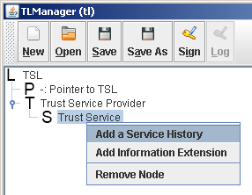
Figure 50: "Trust Service" node contextual menu

The creation of a service history occurs when the status of a service must be updated. For this reason, the user must provide the new values to be set for the current Trust Service:
- The new status of the service;
- The new starting date of this status.
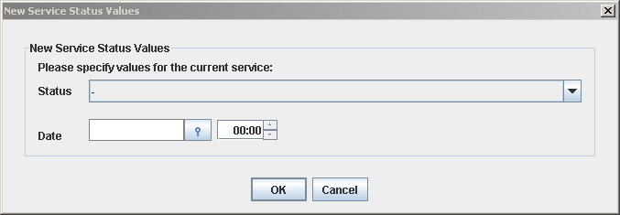
Figure 51: New service status values

Adding a service history has two effects:
- The service current status information are updated with the new status and starting date;
- A new “History” node is created in the navigation tree and the “Service status history” page is displayed:
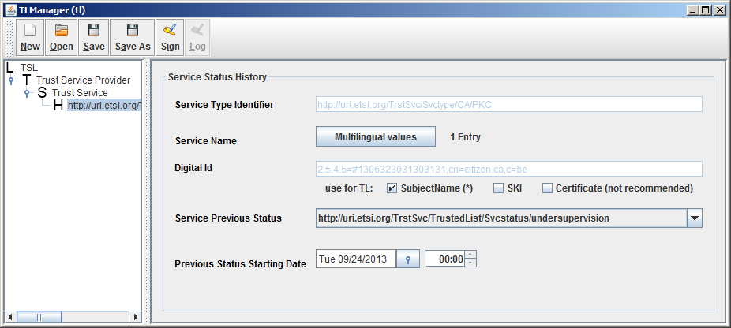
Figure 52: Service status history page

By default, the service status history is pre-filled with the information coming from the service current status information. Parts of them can be modified.

Service Type Identifier
Service type identifier specifies the identifier of the service type. It refers to the service type identifier provided in the “Service current status information” page and cannot be modified. Cf. chapter 3.6.4.1 - Service Type Identifier.

Service Name
The name of the related service can evolve among the different service history entries.
It can be provided in several languages and uses a Multilingual textfield dialog.

Digital ID
The digital identifier of the service cannot be modified and is displayed for information.
In addition, in the same way as in the service current status information page, the user can select which part of the certificate will be used in the Trusted List.
However, as it is not recommended to use the entire certificate inside the service history information, the default choice’s selection is different:
- Certificate: specify that the entire certificate will be included in the TSL. This option is available but not recommended;
- SubjectName: allow the user to add the subject of the certificate in addition of the entire certificate. This option is the default choice;
- SKI: allow the user to add the SKI of the certificate (if present in the certificate).

Service Previous Status
The service previous status specifies the identifier of the previous status of the service. Cf. chapter 3.6.4.4 - Service Current Status.

Previous Status Starting Date
The previous status starting date specifies the date and time on which the previous status became effective. Cf. chapter 3.6.4.5 - Current status Starting Date.

Mandatory fields
The service type identifier and the digital Id cannot be modified in the “service status history” page but are mandatory information retrieved from the “service current status information” page.
Therefore, these 2 values must have been provided before a service history entry can be created.
If one of those values is not present in the governing “service current status information” page, the following error is displayed:
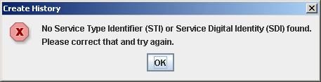
Figure 53: Create service history error

Save the current Trusted List
Clicking on the button “Save” from the main menu saves the current Trusted List.

First Save
If the current Trusted List is saved for the first time, a “Save as” dialog box is opened:
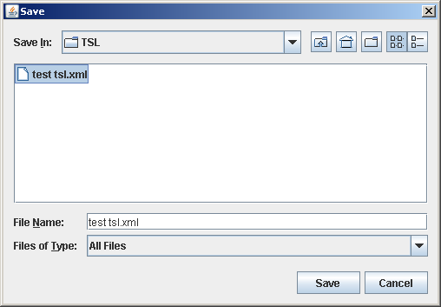
Figure 54: Save dialog box

Sign the current Trusted List
The signature of the Trusted List is the final action to perform on the current list. This signature is achieved using a wizard in 4 steps.

Step 1: Validate the Trusted List
During the first step, TLManager executes the verification of all the rules to be followed. Two kinds of controls are performed during this verification:
- Verification that all mandatory fields are provided;
- Verification that the business rules between the provided information are respected.
In case of any error, the validation result provides the list of all fields requiring a correction. Furthermore, the next step of the wizard is not available until all errors are corrected:
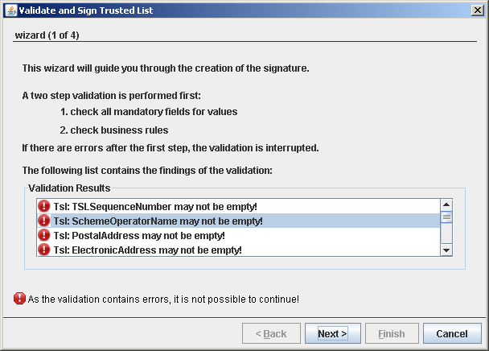
Figure 55: Trusted List validation

Mandatory fields verification
Each page of the Trusted List contains a set of mandatory fields requiring to be verified in order to ensure that the list is complete.

TSL information page:
- TSL sequence number;
- Scheme operator name;
- Scheme operator postal address:
  - Street address;
  - Locality;
  - Country name;
- Scheme operator electronic address:
  - Address type;
  - Electronic address;
- Scheme name;
- Status Determination Approach;
- Scheme information URI;
- Scheme territory;
- Policy or legal notice;
- Historical information period;
- List issue date;
- Next update.

Pointer to other TSL page:
- Digital ID;
- TSL location;
- Scheme operator name;
- Scheme type community rules;
- Scheme territory;
- Mime type.

TSP information page:
- TSP name;
- TSP postal address;
- TSP electronic address;
- TSP information URI.

Service current status information page:
- Service type identifier;
- Service name;
- Digital ID;
- Service current status;
- Current status starting date.

Taken over by extension:
The extension is not mandatory, but if provided the following fields must be filled:
- URI;
- TSP name;
- Scheme operator name;
- Scheme territory.

Additional service information extension:
The extension is not mandatory, but if provided the following fields must be filled:
- Additional information URI.

ExpiredCertsRevocationInfo extension:
The extension is not mandatory, but if provided the following fields must be filled:
- Expired certificates revocation information.

Qualifications extension:
The extension is not mandatory, but if provided the following fields must be filled:
- Qualifier 1;
- Assert attribute;
- Criteria list.
One of the available criteria must be provided.

Service status history page:
- Service type identifier;
- Service name;
- Digital ID;
- Service previous status;
- Previous status starting date.

Business rules verification

TSL information page
List issue date
List the current time.
Next update
The difference between list issued date and next update cannot exceed 6 months.
Sequence number
The sequence number must be an integer and equal or greater than 1.
Scheme name
The scheme name must be a string structured as follows:
- CC:name_value
Where
- CC = the ISO 3166-1 alpha-2 Country Code;
- Name_value = the text filled by the user and describing the name of the scheme.
Scheme territory
The scheme territory value must be in uppercase.
Historical information period
The field historical information period must be equal to 65535.
Scheme type community rule
Depending of the type of TSL, the number of URI(s) to provide must be:
- At least 2 URIs if TSLType = “EUgeneric”;
- Strictly 1 URI if TSLType = “EUlistofthelists”.
Scheme Operator Electronic Address
An email address and a web address must be both present.

Pointer to other TSL
TSLType
If the scheme type is “EUgeneric”, the TSLType of the pointer to other TSL must be “EUlistofthelists”.
If the scheme type is “EUlistofthelists”, the TSLType of the pointer to other TSL must be “EUgeneric”.
Note: The TSLType of the pointer to other TSL is automatically deduced by TLmanager according to the TSLType of the list or rather the mode of TLManager (cf. [R16] for details).
Scheme territory
If TSLType = “EUlistofthelists”, the scheme territory must be “EU”.
Scheme type community rule
Depending of the type of TSL, the number of URI(s) to provide must be:
- At least 2 URIs if TSLType = “EUgeneric”;
- Strictly 1 URI if TSLType = “EUlistofthelists”.

Service current status information page
Unique SDI per service type
The couple “Service type” – “SDI” must be unique in the entire TSL.
Unique Public Key and DN per SDI
Each certificate within a SDI must contain the same public key and the same distinguished name.
Service information extension
If present, the service information extensions list must contain at least one extension.
Current status starting date
The current status starting date must be greater than the time present in the previous status starting date within the most recent service history instance if the status is different.

ExpiredCertsRevocationInfo extension:
Criticality
This extension cannot be set to “critical”
Applicability
This extension can be applied only to the following service type:
- http://uri.etsi.org/TrstSvc/Svctype/CA/PKC
- http://uri.etsi.org/TrstSvc/Svctype/CA/QC
- http://uri.etsi.org/TrstSvc/Svctype/CertStatus/OCSP
- http://uri.etsi.org/TrstSvc/Svctype/CertStatus/CRL

Qualifications extension
Applicability
The qualification extension can be used only if the Service Type Identifier = CA/QC

Service status history page

Service type identifier
The service type identifier in the service history instance must refer to the type identifier described in the governing service.

Service digital identifier
The service digital identifier must refer to the SDI described in the governing service.

Service information extensions
If present, the service information extensions list must contain at least one extension.

Previous status starting date
The previous status starting date in the service history instance must be greater than the time within the previous service history instance if the statuses indicated in both instances are different.

Step 2: Choose the signature method
TLmanager provides 3 different certificate sources:
- PKCS#11;
- PKCS#12;
- MS CAPI.
This choice specifies which certificate will be used to sign the Trusted List.

PKCS#11
In case of PKCS#11:
- Select “PKCS#11” radio button;
- Provide the appropriate library in the signature method.
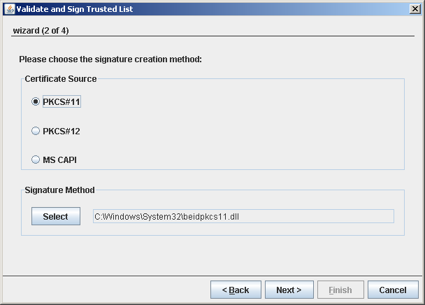
Figure 56: Certificate source and signature method – PKCS#11

PKCS#12
In case of PKCS#12:
- Select “PKCS#12” radio button;
- Provide the “.p12” file signing certificate;
- Enter the corresponding password.
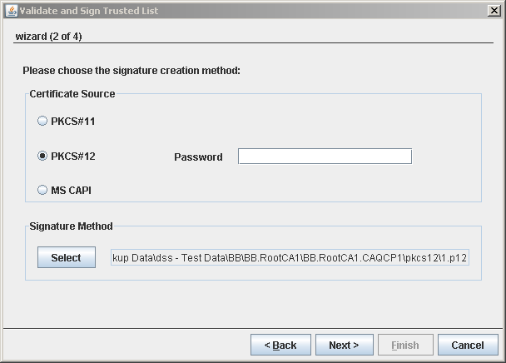
Figure 57: Certificate source and signature method – PKCS#12

MS CAPI
MS CAPI doesn’t require additional information; just select the “MS CAPI” radio button:
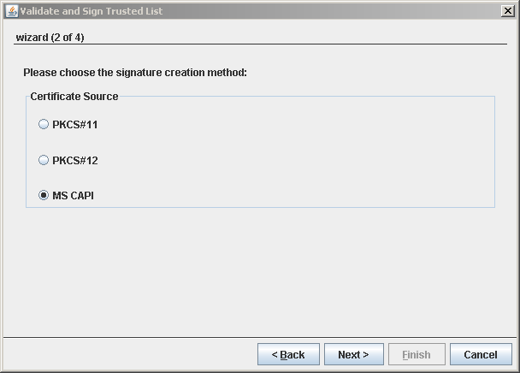
Figure 58: Certificate source and signature method – MS CAPI

Step 3: Select the signing certificate and output file
Depending on the selected certificate source, one or more certificates are available.
The list of all extracted certificates is displayed; the signing certificate can be selected from this list.
Clicking on the button “File” opens a file selection dialog allowing the specification of the destination file where the signed Trusted List will be stored.
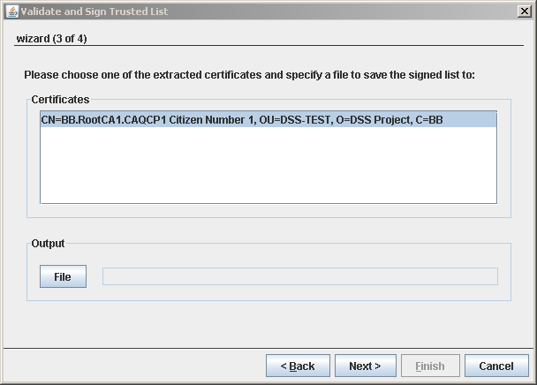
Figure 59: Select signing certificate and destination file

PKCS#11 PIN code
PKCS#11 signature requires the introduction of the PIN code related to the smart card.
A specific interface is displayed and allowing the user to provide his private PIN code.
Note: The specific interface is driver dependent; it varies from one smart card to another.
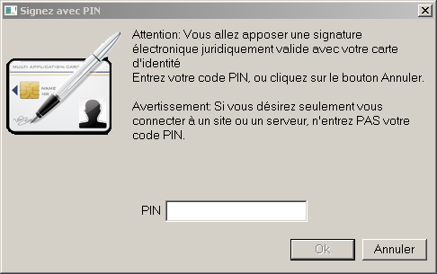
Figure 60: Example of PKCS#11 PIN introduction

MS CAPI PIN code
MS CAPI signature also requires the introduction of the correspondent private PIN code in order to finalise the signature.
However, a common interface is provided regardless of the smart card.
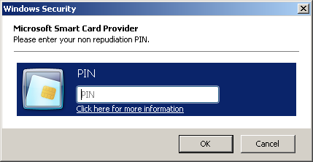
Figure 61: MS CAPI PIN code introduction

Step 4: Signature confirmation
Finally, the fourth and last step of the wizard just displays a confirmation about the process:
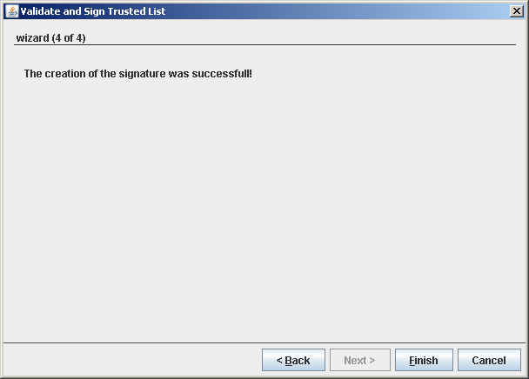
Figure 62: Signature confirmation

Consult the validation result
In case of errors during the first step of the signature wizard, the validation results can be viewed independently from the wizard.
This functionality eases the correction of the erroneous fields as with each click on an error entry, the appropriate content page is shown.
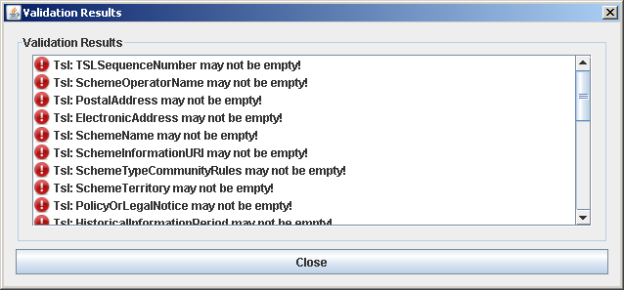
Figure 63: Validation results

Remove a TSL element
The structure of the Trusted List can be edited at any time. Every element of the navigation, except the “TSL” root of the tree, can be removed. It is accessible from the context menu of each node from where it is available (cf. chapter 3.6 - Edit a Trusted List).

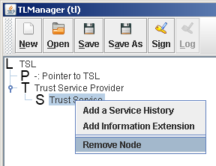
Figure 64: Example of contextual menu

Right click on the corresponding node to display its contextual menu and click on “Remove node”.
A warning is displayed to confirm the action:
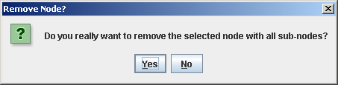
Figure 65: Confirm removal

Note: Once the removal is confirmed, the node and all its sub-nodes are removed and this cannot be undone.

Annex I: Editing modes of TLManager
There are two different running modes for TLManager that define the type of TSL that can be created:
- Tl-mode: used to work with normal Trusted Lists for Member States;
- Lotl-mode: used to work with the List of Trusted Lists.
Moreover, there a two other running modes that define the scope of the TSL:
- EU mode: used to work with Trusted List or List of Trusted List in the scope of EU member states;
- NON EU mode: to work outside the scope of EU member states.
There are two different sections in the configuration file for TLManager (cf. [R16] for details) whose configuration values are shown in the following tables:

Trusted List configuration
The following table defines the values for a Trusted List:
Trusted list element | Configuration file default value
TrustedServiceStatusList TSLTag | http://uri.etsi.org/02231/TSLTag
VersionIdentifier | 4
TSLType | EU: http://uri.etsi.org/TrstSvc/TrustedList/TSLType/EUgeneric  NON EU: http://uri.etsi.org/TrstSvc/TrustedList/TSLType/#CC#list
StatusDeterminationApproach | EU: http://uri.etsi.org/TrstSvc/TrustedList/TSLType/StatusDetn/EUappropriate  NON EU : http://uri.etsi.org/TrstSvc/TrustedList/TSLType/StatusDetn/#CC#determination
SchemeTypeCommunityRules | http://uri.etsi.org/TrstSvc/TrustedList/schemerules/EUcommon http://uri.etsi.org/TrstSvc/TrustedList/schemerules/CC
Pointer to other TSL – TSLType | EU: http://uri.etsi.org/TrstSvc/TrustedList/TSLType/EUlistofthelists  NON EU: http://uri.etsi.org/TrstSvc/TrustedList/TSLType/#CC#listofthelists
Mime Type | - application/pdf  - application/vnd.etsi.tsl+xml
Country code | The selection of available country codes (Cf. chapter II in [R17]).
Language code | The selection of available language codes (Cf. chapter II in [R17]).
Address type | - mailto:  - http://  - https://
Service type identifier | - http://uri.etsi.org/TrstSvc/Svctype/CA/PKC  - http://uri.etsi.org/TrstSvc/Svctype/CA/QC  - http://uri.etsi.org/TrstSvc/Svctype/TSA  - http://uri.etsi.org/TrstSvc/Svctype/TSA/QTST  - http://uri.etsi.org/TrstSvc/Svctype/TSA/TSS-QC  - http://uri.etsi.org/TrstSvc/Svctype/TSA/TSS-AdESQCandQES  - http://uri.etsi.org/TrstSvc/Svctype/Certstatus/OCSP  - http://uri.etsi.org/TrstSvc/Svctype/Certstatus/OCSP/QC  - http://uri.etsi.org/TrstSvc/Svctype/Certstatus/CRL  - http://uri.etsi.org/TrstSvc/Svctype/Certstatus/CRL/QC  - http://uri.etsi.org/TrstSvc/Svctype/RA  - http://uri.etsi.org/TrstSvc/Svctype/RA/nothavingPKIid  - http://uri.etsi.org/TrstSvc/Svctype/ACA  - http://uri.etsi.org/TrstSvc/Svctype/SignaturePolicyAuthority  - http://uri.etsi.org/TrstSvc/Svctype/NationalRootCA-QC  - http://uri.etsi.org/TrstSvc/Svctype/Archiv  - http://uri.etsi.org/TrstSvc/Svctype/REM  - http://uri.etsi.org/TrstSvc/Svctype/EDS  - http://uri.etsi.org/TrstSvc/Svctype/EDS/Q  - http://uri.etsi.org/TrstSvc/Svctype/PSES  - http://uri.etsi.org/TrstSvc/Svctype/PSES/Q  - http://uri.etsi.org/TrstSvc/Svctype/IdV  - http://uri.etsi.org/TrstSvc/Svctype/KEscrow  - http://uri.etsi.org/TrstSvc/Svctype/PPwd  - http://uri.etsi.org/TrstSvd/Svctype/TLIssuer  - http://uri.etsi.org/TrstSvc/Svctype/unspecified
Service status | - http://uri.etsi.org/TrstSvc/TrustedList/Svcstatus/undersupervision  - http://uri.etsi.org/TrstSvc/TrustedList/Svcstatus/supervisionincessation  - http://uri.etsi.org/TrstSvc/TrustedList/Svcstatus/supervisionceased  - http://uri.etsi.org/TrstSvc/TrustedList/Svcstatus/supervisionrevoked  - http://uri.etsi.org/TrstSvc/TrustedList/Svcstatus/accredited  - http://uri.etsi.org/TrstSvc/TrustedList/Svcstatus/accreditationceased  - http://uri.etsi.org/TrstSvc/TrustedList/Svcstatus/accreditationrevoked .
Qualifier | - http://uri.etsi.org/TrstSvc/TrustedList/SvcInfoExt/QCWithSSC  - http://uri.etsi.org/TrstSvc/TrustedList/SvcInfoExt/QCNoSSCD  - http://uri.etsi.org/TrstSvc/TrustedList/SvcInfoExt/QCSSCDStatusAsInCert  - http://uri.etsi.org/TrstSvc/TrustedList/SvcInfoExt/QCForLegalPerson  - http://uri.etsi.org/TrstSvc/TrustedList/SvcInfoExt/QCStatement
Assert attribute | - all  - one  - none
Key usage | - Digital signature  - Non repudiation  - Key encipherment  - Data encipherment  - Key agreement  - Key CertSign  - CRL signature  - Encipher only  - Decipher only
Additional service information URI | - http://uri.etsi.org/TrstSvc/TrustedList/SvcInfoExt/RootCA-QC

List of Trusted List configuration
The following table defines the values for a List of Trusted List:
LOTL element | Configuration file default value
TrustedServiceStatusList TSLTag | http://uri.etsi.org/02231/TSLTag
VersionIdentifier | 4
TSLType | EU: http://uri.etsi.org/TrstSvc/TrustedList/TSLType/EUlistofthelists  NON EU: http://uri.etsi.org/TrstSvc/TrustedList/TSLType/#CC#listofthelists
StatusDeterminationApproach | EU: http://uri.etsi.org/TrstSvc/TrustedList/TSLType/StatusDetn/EUappropriate  NON EU : http://uri.etsi.org/TrstSvc/TrustedList/TSLType/StatusDetn/#CC#determination
SchemeTypeCommunityRules | http://uri.etsi.org/TrstSvc/TrustedList/schemerules/EUlistofthelists
Pointer to other TSL – TSLType | EU: http://uri.etsi.org/TrstSvc/TrustedList/TSLType/EUgeneric  NON EU: http://uri.etsi.org/TrstSvc/TrustedList/TSLType/#CC#list
Mime Type | - application/pdf  - application/vnd.etsi.tsl+xml
Country code | The selection of available country codes (Cf. chapter II in [R17]).
Language code | The selection of available language codes (Cf. chapter II in [R17]).
Address type | - mailto:  - http://  - https://

End of Document

